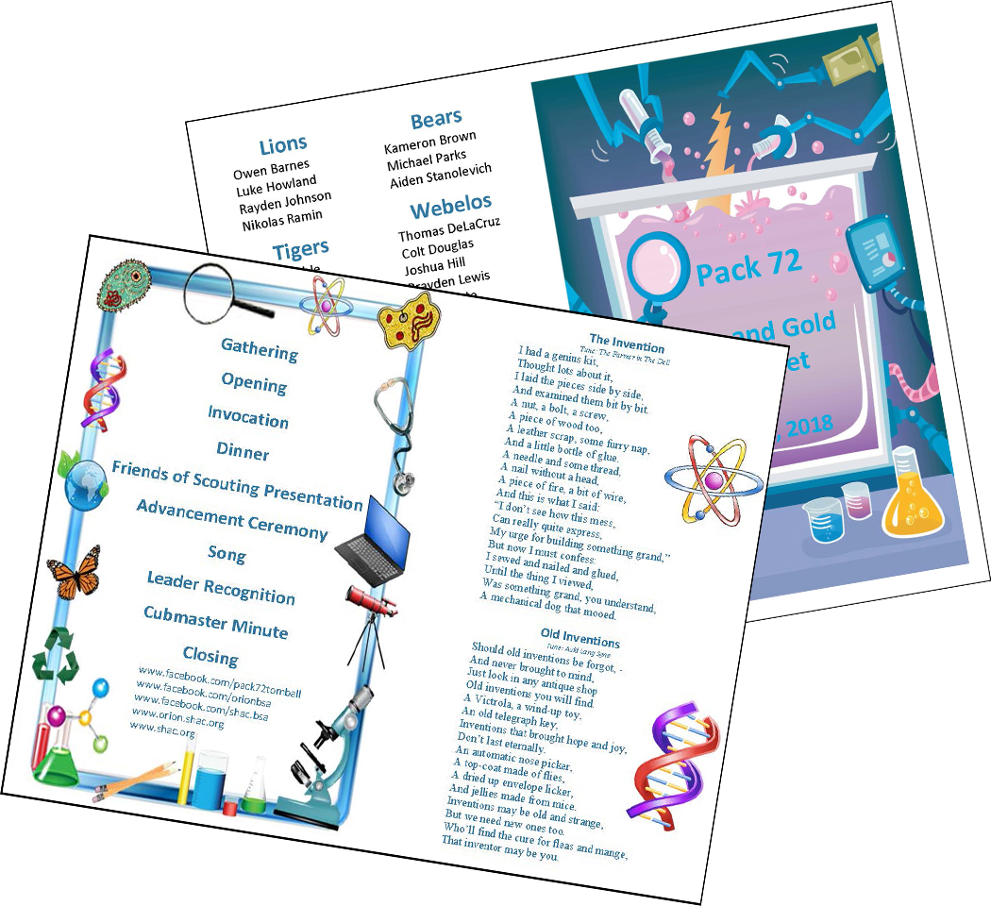
Blue and Gold Banquet
Science Theme

Blue and Gold Banquets: Most packs celebrate Scouting Anniversary Week in February with a birthday party called the blue and gold banquet. It brings families together for an evening of fun and cheer. It's often the pack meeting for February. shac.org/science-theme

The purpose of the blue and gold banquet is to celebrate the pack's anniversary, thank pack leaders and other adults who have helped the pack, and inspire the leaders, Scouts, and parents. The banquet can be like a regular pack meeting with songs, skits, stunts, and awards. Or it can be something different and a little more special. Your pack may decide to bring in an entertainer such as a magician or a storyteller. Or you could have a video or slide show of what the pack did over the past year. A good banquet needs lots of planning.

Careful planning is necessary for the banquet to be successful. Most packs begin planning at least two months in advance. The pack committee should recruit a banquet chair, who in turn may select others to carry out the responsibilities of the program, such as making physical arrangements, handling invitations, choosing a theme, etc. Try to involve as many people as possible, but avoid giving den leaders too many additional responsibilities because it may distract them from their duties to their dens.

A detailed plan for the blue and gold banquet, including a planning calendar, sample agenda, and suggested program activities, is available in the Cub Scout Leader How-To Book.

If you find these resources helpful, or have comments or additional resources we can add, please let us know by sending us a message to our Facebook page at www.facebook.com/shac.bsa?
Content  (Sources: Baloo’s Bugle Power Up (Sept 2012), Reinventing the Wheel (Apr 1997)  Program Details  Podium Script  Printed Program  Additional ideas:  Gathering Activities  Opening Ceremonies  Run-ons & Jokes  Skits  Songs  Audience Participation  Games  Closing Ceremonies  Cubmaster Minute  Theme Related Stuff  Decorations | Blue and Gold Placemats  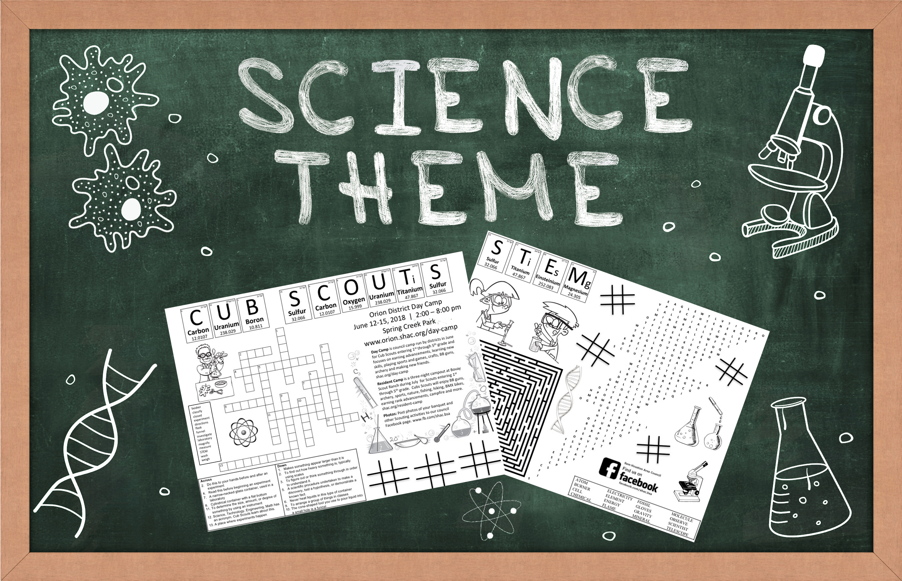  Free, customizable placemats are available for packs to use at blue and gold banquets and den leaders to use during den meetings to help promote day camp. Download placemats at  shac.org/science-theme.

SHAC Pinterest page: www.pinterest.com/samhoustonbsa/science-theme/
Banquet Planning: www.skcscouts.org/wp-content/uploads/2013/06/Blue-Gold-Planning-Guide.pdf
Banquet Planning: www.ocbsa.org/wp-content/uploads/2011/06/Blue-Golf-Banquet-for-Website.pdf

Program Details

Welcome
Cubmaster: Welcome the Cub Scouts, parents and leaders. Recognize special guests.

Opening: Genius Night
Personnel: 7 Cubs - 6 Holding cards with pictures of the inventions.
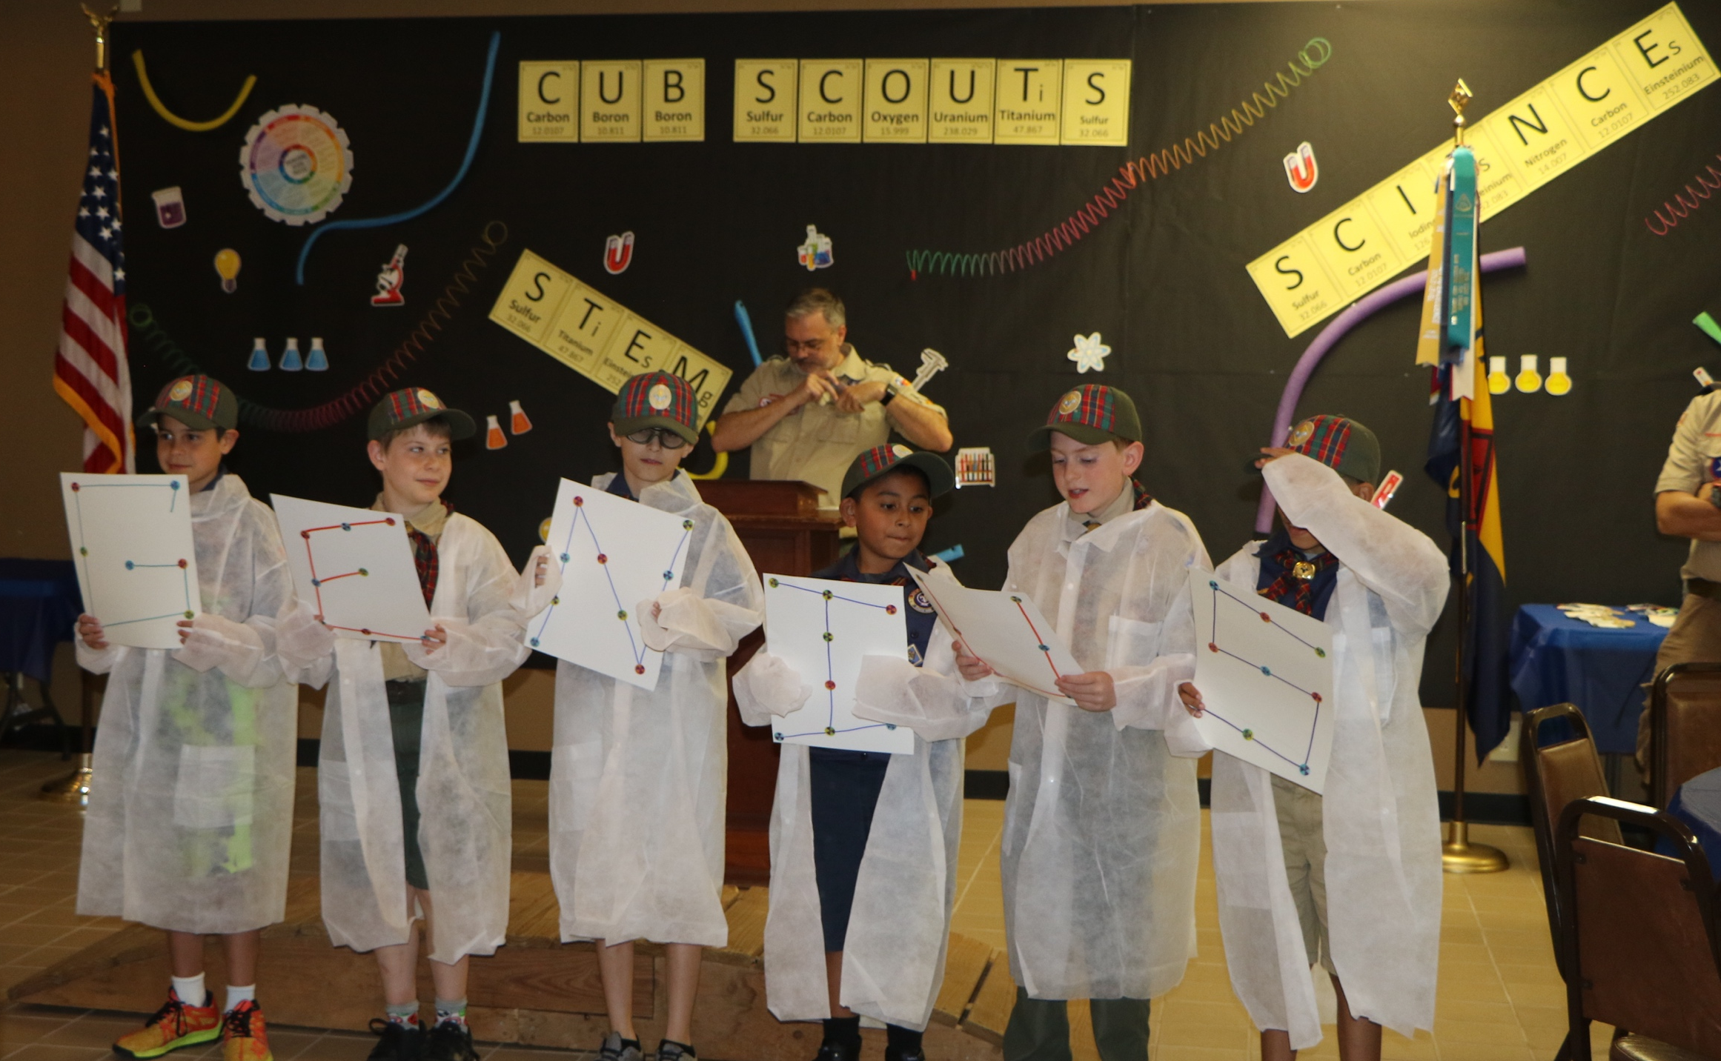
Cub Scout #1: G is for Gutenberg invented the moveable type for printing, so that now we can have books, papers and magazines to read.
Cub Scout #2: E is for Edison gave us many electrical ideas, but perhaps his greatest was the light bulb to help light up our world.
Cub Scout #3: N is for Newton discovered gravity and worked with electricity.
Cub Scout #4: I is for Irving was a genius with his pen. He wrote many stories, which young and old have enjoyed for ages.
Cub Scout #5: U is for Urey made his discoveries in chemistry and nuclear power, which will be used for many generations.
Cub Scout #6 The “S” stands for “Scouting,” which helps every Cub Scout develop genius in his very own way.
Cub Scout #7: Now let us salute the genius that is in every Cub Scout by standing and saying our pledge to the flag of our country.

Pledge

Invocation

Dinner

FOS Presentation

Special Program / Guest – Mad Scientist

Song

Den leads a song in the program. Additional songs can be found here.

Leader Recognition

Skits and Audience Participation, optional
Skits and Audience Participation may not be needed if there is a guest speaker.

Advancement Ceremony – Color Changing Ceremony
- Food coloring (orange, yellow, green, blue, red), good quality (e.g., find in baking section of Hobby Lobby or Michaels),
- 5-6 containers of water with just enough water to fill up the glass tube (six if the Bobcat badge is being presented)
- 5-6 clear plastic glass tubes (hint: purchase from Hobby Lobby at 50% off)
- Cub Scout signs on front of each container
- Dry ice (purchased day of event – many grocery stores carry dry ice)
- Cooler for dry ice
- Tongs or gloves – do not touch dry ice
- Hammer to break up dry ice
- Saran wrap
- Tinsel or other decoration to hide bottom of glasses.

Setup:
Before the ceremony, place a few drops of food coloring in each container of water. Practice ahead of time to determine how many drops will be needed based on amount of water used. It will take more yellow drops and less of other colors (too much blue food coloring will look black and not the right amount of red can look pink). Place a small amount of seran wrap on top of food coloring so the food coloring doesn’t react with dry ice. Place a chunk of dry ice in glass (about 2” cubed). Be sure the audience does not see the preparation or the bottom of the glasses during the ceremony. Have the glass tubes on the podium or a table. Notify the den leaders to pick up the containers of water sitting on a table to the side before coming to the front.

CUBMASTER (CM): Call up the den leaders. The den leader has some water that they will pour into our magical vases. Now you may ask, what makes these vases magical. Well, if and only if all of the Scouts in the den have completed all of the requirements to earn the rank, something magical will happen.

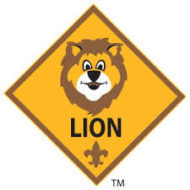
CM: (call up Lions and their parents). Den leader (name), have all of these Scours completed all of the requirements for the Lion badge? (wait for response). Ok, let’s see (leader pours water into the glass tube). Yellow symbolizes the spirit of Scouting which is present in all the Lion Scouts. (present Lion rank). Lead cheer.

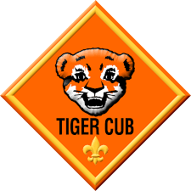
CM: (call up Tigers and their parents). Den leader (name), have all of these Scours completed all of the requirements for the Tiger badge? (wait for response). Ok, let’s see (leader pours water into the glass tube). Orange symbolizes the enthusiasm and creativity the Tigers used while earning the Tiger rank.
(present Tiger rank). Lead cheer.
CM: (call up Wolves and their parents). Den leader (name), have all of these Scours completed all of the requirements for the Wolf badge? (wait for response). Ok, let’s see (leader pours water into the glass tube). Green symbolizes the earth which the Wolves learned about and discovered. (present Wolf rank). Lead cheer.
CM: (call up Bears and their parents). Den leader (name), have all of these Scours completed all of the requirements for the Bear badge? (wait for response). Ok, let’s see (leader pours water into the glass tube). Blue represents the sky which is limitless, like the many adventures that the Bear Scouts encountered. (present Bear rank). Lead cheer.

CM: (call up 4th grade Webelos Scouts and their parents). Den leader (name), have all of these Scours completed all of the requirements for the Webelos badge? (wait for response). Ok, let’s see (leader pours water into the glass tube). Red represents courage. The Webelos Scouts have been learning to be brave and to stand up for what is right. (present Webelos rank). Lead cheer.

Option 2 (if Bobcat and Arrow of Light ranks need to be presented):

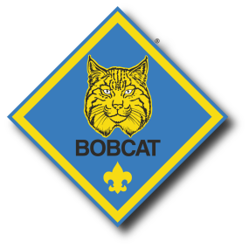
CM: (call up Scouts who have earned the Bobcat badge and their parents). Parents, have all of these Scours completed all of the requirements for the Bobcat badge? (wait for response). Ok, let’s see (leader or one of the parents pour water into the glass tube). Purple represents wisdom. These Scouts have learned the meaning of Scout Oath and Law. (present Bobcat rank). Lead cheer.

CM: (call up 4th grade Webelos Scouts and their parents). Den leader (name), have all of these Scours completed all of the requirements for the Webelos badge? (wait for response). Ok, let’s see (leader pours water into the glass tube). Brown represents reliability. The Webelos Scouts have been learning some of the skills that will be needed to be a reliable Scout in a troop. (present Webelos rank). Lead cheer.
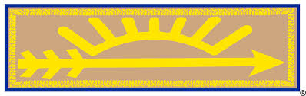
CM: (call up 5th grade Webelos Scouts and their parents). Den leader (name), have all of these Scours completed all of the requirements for the Arrow of Light badge? (wait for response). Ok, let’s see (leader pours water into the glass tube). Red represents courage. The Webelos Scouts have been learning to be brave and to stand up for what is right. (present Arrow of Light rank). Lead cheer.

Cubmater Minute
Work while you work. play while you play.
One thing at a time, that is the way.
All that you do, do with all your might.
Things done halfway are not done right.
What you are is God’s gift to you.
What you make of yourself is your gift to God.
Make it a good gift.

Closing Ceremony
Use the same posters as the opening ceremony.

- Everyone cannot be brilliant, everyone cannot be smart. I may not be a genius, but I can build a neat go-cart.
- Everyone has a spark of genius in them just waiting to be lit. If they’ll jump into things and not just sit.
- I can’t solve a chemical equation or explain Newton’s rule, but I can make a peanut butter sandwich that will really make you drool.
- Although we may not go down in history as the genius of our day. We can help others in this world to travel life’s way.
- By sharing our sparks of genius with others that we know. Thus, helping ideas, along the way to grow and glow.
- I have lots of ideas without a doubt and I know I am a genius at being a Cub Scout!
- Remember the spark of an idea we may share with a friend. Can be added to by others and become a genius idea in the end.
Begin closing flag ceremony.

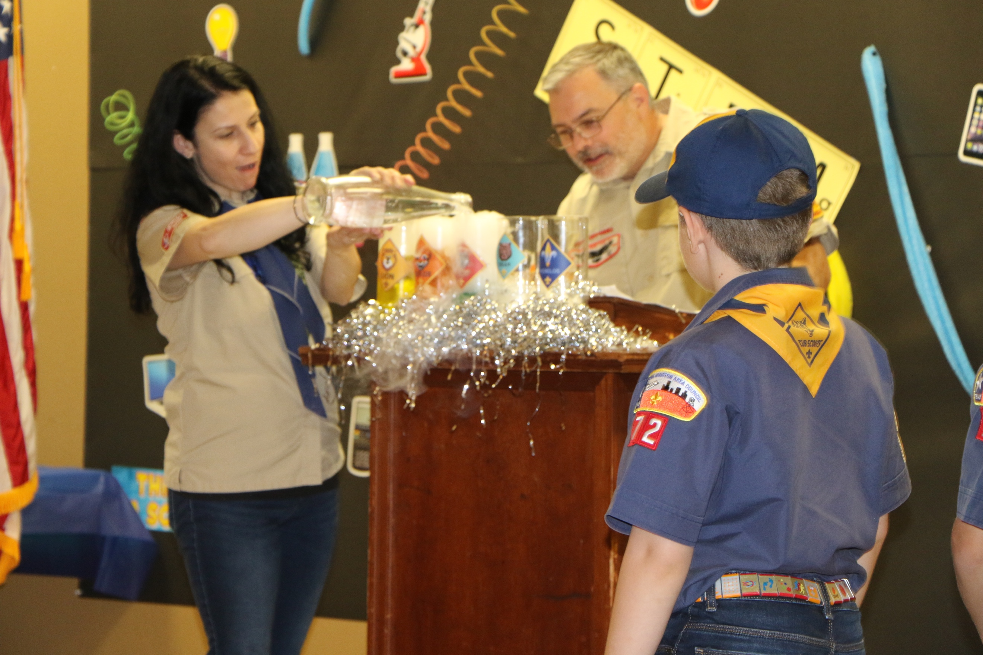

Print for Advancement Ceremony Props. The size of graphics may need to be adjusted depending on the size of the glass tubes.
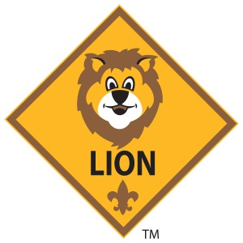

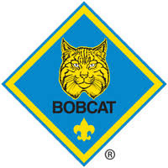

Podium Script: Invocation

Would the audience please rise (pause).

Scouts, family members and friends let us take this moment to offer a prayer according to your tradition.

Here in Your presence many friends and families are gathered to celebrate in fellowship the achievements and accomplishments of these young Cub Scouts.

We thank You for this fellowship and for helping these families to give their sons the opportunity to grow and learn to do their best at all they try.

For the blessing of abundant food to nourish us in spirit and in body we give You thanks.

Open the heart of each Scout to realize their duty to You and promise to help others and give their parents joy and patience as they learn and try new things.

We give thanks for our families and our Scouts for their resourceful and creative minds. Help us to encourage their creativity and individuality. Amen

Podium Script: Advancement Ceremony

Call up the den leaders. The den leader has some water that they will pour into our test tube. If and only if all of the Scouts in the den have completed all of the requirements to earn the rank, we will see a chemical reaction.

Call up Lions and their parents.
Den leader (name), have all of these Scours completed all of the requirements for the Lion badge? Wait for response.
Ok, let’s see. Leader pours water into the glass tube.
Yellow symbolizes the spirit of Scouting which is present in all the Lion Scouts.

Orange symbolizes the enthusiasm and creativity the Tigers used while earning the Tiger rank.

Green symbolizes the earth which the Wolves learned about and discovered.
Blue represents the sky which is limitless, like the many adventures that the Bear Scouts encountered.

Red represents courage. The Webelos Scouts have been learning to be brave and to stand up for what is right.

Podium Script: Cubmaster Minute

Work while you work. play while you play.

One thing at a time, that is the way.

All that you do, do with all your might.

Things done halfway are not done right.

What you are is God’s gift to you.

What you make of yourself is your gift to God.

Make it a good gift.

Print: Cheers and Applause's
cut into strips and put in Cheer box
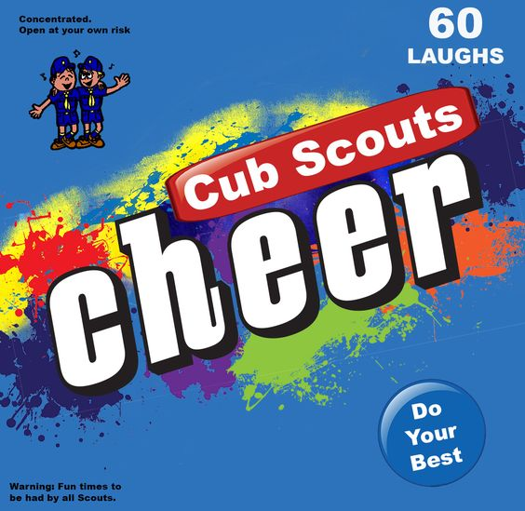
Cheers add fun to meetings and campfire programs. Use cheers during Cub Scout den meetings, pack meetings, or campfires. The cheer graphic can be printed and attached to a blue bag or a box wrapped in blue construction paper. Stuff the cheer box with themed cheers written on strips of paper before each meeting. Someone (e.g., assistant Cubmaster) should be assigned to jump up and enthusiastically lead cheers throughout the meeting (e.g., after a skit or advancement ceremony). Download the graphic at www.shac.org/Data/Sites/1/media/resources/leader-guides/Cheer-Box-1200x1170.jpg

Applause stunts are a great way to recognize a person or den in a pack meeting for some accomplishment they have performed. Be sure before you start that everyone knows and understands the applause stunt and how to do it. Applause stunts serve more than one purpose -- they not only provide recognition but also help liven up a meeting. Applause stunts need to be fun. Strive for quality of performance in your stunts. Another important side effect of Applause stunts is they provide” wiggle time” for all the Scouts and siblings during the ceremonies so they sit still during the serious moments. It is a lot easier and a lot less stressful to lead a cheer and have fun than to be constantly reminding the Scouts to sit quietly.

Invention Cheer: I’ve made it, I’ve made it. Don’t know what it is, but I’ve made it!

Magic Cheer: Put hand up sleeve then pull it out and shout “Sha-zam”!

Mad Scientist Cheer: Hold an imaginary test tube up in one hand and pour into it with the other hand. Shake it then shout “BOOM”! Then say – “That was exciting!”

Ben Franklin Cheer Hold both hands out in front of you as if flying a kite. Jerk back suddenly while saying, "Zap, Zap, Zap."(Lightning). That was enlightening!

Electricity Applause: Place both index fingers together and say “Zip, zap, zop!”

Oil Well Applause: Stand up, place both hands overhead and hook thumbs together, Wiggle fingers and say “Gush, gush, gush!”

Solar Power Applause: Pretend to slather on suntan lotion, put on sunglasses and sunbathe. Say “The sun—It’s a gas!”

Mad Scientist Applause: Pretend to hold up a test tube in one hand. Pour something into it, then add something else, then yell, “BOOM!”

Electricity: “It’s electric!”

Lightning - Shake your finger like jagged lightning and go "Shh Shah" on each jagged movement. To add thunder - add a "BOOM" after every 4 +/- lightning jags or so.

Livewire - Pretend to Grab onto a live electrical wire and shake the whole body, while saying "ZZZZZZZ".

Extension Cord Yell - Plug it in! Plug it in! Plug it in!
Where is the electric? Where is the electric? Where is the electric? Use your muscles! Use your muscles! Use your muscles!

Electric Power Applause: Hold up and shake your finger while saying “ZZZZZZ”

Solar Power Applause: Use your hands and arms to make the circle of the Sun, then say “Solar Power Up!” while pointing to the sky

Wind Power Applause: Use one arm and hand to describe a windmill turning, while you say “Whoooo, Whooo, Whooo” (the sound of wind)

Water Power Applause: Use one hand and arm to make “waves” while you shout “Water Power – Power Up!”
Opening Ceremony: Print for back of posters
#1 - G: Opening:

G is for Gutenberg invented the moveable type for printing, so that now we can have books, papers and magazines to read.

Closing:

Everyone cannot be brilliant, everyone cannot be smart. I may not be a genius, but I can build a neat go-cart.
#2 - E: Opening:

E is for Edison gave us many electrical ideas, but perhaps his greatest was the light bulb to help light up our world.

Closing:

Everyone has a spark of genius in them just waiting to be lit. If they’ll jump into things and not just sit.

#3 - N: Opening:

N is for Newton discovered gravity and worked with electricity.

Closing:

I can’t solve a chemical equation or explain Newton’s rule, but I can make a peanut butter sandwich that will really make you drool.
#4 - I: Opening:

I is for Irving was a genius with his pen. He wrote many stories, which young and old have enjoyed for ages.

Closing:

Although we may not go down in history as the genius of our day. We can help others in this world to travel life’s way.
#5 - U: Opening:

U is for Urey made his discoveries in chemistry and nuclear power, which will be used for many generations.

Closing:

By sharing our sparks of genius with others that we know. Thus, helping ideas, along the way to grow and glow.
#6 - S: Opening:

The “S” stands for “Scouting,” which helps every Cub Scout develop genius in their very own way.

Closing:

I have lots of ideas without a doubt and I know I am a genius at being a Cub Scout!
(print on a note card – add flag ceremony script)
#7 – Opening

Now let us salute the genius that is in every Cub Scout by standing and saying our pledge to the flag of our country.

Closing:

Remember the spark of an idea we may share with a friend. Can be added to by others and become a genius idea in the end.

GATHERING ACTIVITIES

Find A Name
Find and circle the last name of these famous inventors –
Sir Isaac Newton Aristotle
Galileo Michelangelo
Louis Braille James Watt
Leonardo DaVinci Joseph Lister
Robert Fulton Albert Einstein
Guillermo Marconi Ernie Levassor
Eli Whitney Orville Wright
George Eastman George Washington Carver
John Logie Baird Thomas Edison
Alexander Fleming William Kalff
Werner von Braun Johannes Gutenberg
Alfred Nobel Robert Watson Watt
Roger Bacon Madame Curie

Copy and enlarge this word search before trying to solve it.
Who Invented It?
Each of the following inventions has played an important part in modern industrial development. Who invented each of them?
1. Telephone A. Edmund Cartwright
2. Phonograph B. Cyrus McCormick
3. Telegraph C. Samuel F. B. Morse
4. Dynamite D. The DuPont Company
5. Power Loom E. Thomas Alva Edison
6. Steamboat F. Galileo
7. Reaper G. Charles Goodyear
8. Vulcanized rubber H. Alexander Graham Bell
9. Nylon I. Sir Alexander Fleming
10. Thermometer J. Robert Fulton
11. Penicillin K. Wilbur and Orville Wright
12. Airplane L. Alfred Nobel
Answers: 1-H, 2-E, 3-C, 4-L, 5-A, 6-J, 7-B, 8-G, 9-D,
10-F, 11-I, 12-K
Computerize
Equipment Pencil and paper
Test your computer jargon and match the word with the correct definition.
KEYBOARD SOFTWARE MONITOR
FLOPPY DISK DISC DRIVE HARDWARE
RAM BIT
- It reads and stores information between the disk and the computer
- It’s much like a typewriter and feeds information and commands to the computer
- What is the screen that displays the computers output?
- Computer temporary memory that can be changed or edited.
- It means binary digit and it’s the only symbols computers understand.
- The actual physical, hard, computer components like screen, keyboards, printer, etc.
- Flexible plastic disk used to write electronic information magnetically.
- A set of instructions that tell your computer what to do. BIT
Answers
1 – Disk Drive 2 – Keyboard 3 – Monitor
4 – Ram [random access memory] 5 – Bit,
6 – Hardware 7 – Floppy disk 8 – Software
Tower Building
Have an assortment of “blocks” made from scrap lumber, all sizes and shapes. Cub Scouts take turns stacking blocks of wood, forming a tower, one at a time. How tall can the tower grow before it tumbles? The object is to not be the one that causes the stack to fall.

Cardboard Drop
You will need a piece of cardboard about 8” square and a button in front of each standing player. The idea of this game is to drop the cardboard so it falls on the button and covers it. This is tricky because the cardboard will swirl as it falls. A player may pick up is cardboard and try as many times as they like. The cardboard must be held with only one hand.

Pack Gathering Activity
Set up display tables for Cub Scouts’ genius kit designs. A committee of parents could be recruited to place colorful stickers on every display. Make sure every Cub Scout is recognized for their efforts by presenting Genius Night Certificates of Merit or other suitable memento.

OPENING CEREMONIES

Professor Plop Opening
Setting Cubmaster with Professor Plop (adult dressed appropriately) and his special invention
Cubmaster We have called in a ceremony specialist to help us tonight. I would like for you to meet Professor Plop from M.I.T. (Mighty Ingenious Tech)
Professor I’m still working on my special invention. It’s not quite perfected yet, but I’m close.
Cubmaster That looks like quite a gadget.
Professor It is, it is!
Cubmaster Well, we’ll get on with our pack meeting and let you continue your work. Den _____ has our opening flag ceremony this evening.
Periodically during the pack meeting, the CM calls attention to the Professor Plop and checks to see how he is coming along. The invention is part of the closing!!

Light Up Your Life
Setting: A single light bulb is illuminated in the front of a darkened room.
Cubmaster: This light bulb is a pretty commonplace thing to people these days. But it’s a fitting symbol for our science night because of what it represents. Its inventor, Thomas Edison, was recognized as a genius – one of the great inventors of all time. But even more, he represents what you can accomplish if you remember to live up to that part of the Cub Scout promise that says you will “Do Your Best”. Even if you don’t invent a better light bulb, I hope each one of you will do your best, and not stumble around in the darkness, complaining about what everyone else is doing.
Turn up the house lights.
Color guard posts the colors
Scouts leads the Pledge of Allegiance.
This could also be a good Cubmaster’s minute
INVENTORS
Need 9 Cub Scouts. Make poster boards with the letter and a picture of the item. Have the script on the back in LARGE print.

I—IODINE-- Iodine has many uses. It is a disinfectant and a nutrient added to salt to prevent diseases. It was discovered by accident. In 1811 Bernard Courtois was extracting sodium and potassium compounds from seaweed ash. Once the compounds were gone, he added sulfuric acid. A violet cloud erupted from the mass. The gas condensed on metal objects in the room.
N—NYLON-- Wallace Carothers is considered to be the father of man-made polymers. In 1928 Dupont opened a research lab to try to make a fabric that would replace silk. Japan was the source for silk for this country and trade relations were breaking apart. World War II was about to break out. They were able to create nylon by 1934 and nylon stockings were pretty, durable and very desirable.

V—VACUUM CLEANER-- James Murray Spangler, a janitor in a Canton, Ohio department store, deduced that the carpet sweeper he used was the source of his cough. He tinkered with an old fan motor and attached it to a soapbox stapled to a broom handle. Using a pillowcase as a dust collector on the contraption. He formed the Electric Suction Sweeper Company. William Hoover, a cousin in-law, went into business with him and they renamed it. Sluggish sales were given a kick by Hoover’s 10 day, free home trial, and eventually there was a Hoover® vacuum cleaner in nearly every home.

E—ELASTIC-- Thomas Hancock invented a machine called a masticator, which shredded rubber scraps. In 1820 he patented elastic fastenings for gloves, shoes, and stockings. In 1821 he joined forces with Charles Macintosh and they produced rubber imbedded raincoats. The raincoats improved when vulcanized rubber was invented by Charles Goodyear.

N—NEON-- When electricity was discovered scientists moved towards various types of lighting. George Claude applied an electrical discharge to a sealed tube of neon gas in 1902. He formed a company called Claude Neon and introduced neon gas signs to the United States in 1923 when he sold a sign to a Packard car dealership in Los Angeles. They paid $24,000 for two signs. Neon quickly became a popular feature in outdoor advertising.

T—TELEVISION-- Philo Farnsworth was born in Beaver City, Utah. They moved to Rigby, Idaho and at 14 years old, while plowing a potato field back and forth he got the idea that electron beams could scan images the same way. At 15, with only 2 years of High School, he gained admission to BYU. He credited his High School teacher for helping him succeed.

O—OXYGEN TENT-- John Emerson, born in New York, disappointed his father when he did not want to attend an Ivy League college but instead wanted to buy a machine shop and tinker with his ideas. His mother financed the purchase and he came up with a device for tissue respiration. In 1931, he came up with the oxygen tent. He is best known for the iron lung, which during the polio epidemic in the 1930s saved many lives.
R— RUBBER-- Explorers found the South American natives using a sticky substance that bounced. They brought it to Europe but it had a big problem, the instant its temperature changed it deteriorated and became rotten and smelly. Charles Goodyear became obsessed with trying to solve the rubber dilemma. He tried everything until in 1839 he accidentally spilled rubber mixed with sulphur on a hot stove. He was awarded the patent for Vulcanization and happily spent the rest of his life obsessed with inventing practical uses for rubber. When he died, he was $200,000 in debt.

S—STAMPS-- The first official mail office was opened in England in 1516. Nearly 300 years later [1835] Sir Rowland Hill suggested that letters under an ounce should be carried for a uniform fee of 1 Penny and used a stamp. Until this time the receiver paid the fee on receiving the letter. The United States started using stamps in 1845.

Genius Night
Personnel - 5 Cub Scouts with graduation hats on and numbers 1-5 on their shirts, 2 judges and MC.
MC: To begin the pack meeting tonight, a panel of judges will decide who the real genius is among these Cub Scouts. Tell us why you feel that you should be called a genius.
- I’m the genius because I discovered the hamburger.
- No! I’m the genius because I invented the television.
- No! I’m the genius because I got all A’s on my report card.
- No! I’m the genius because I can play the guitar, juggle oranges and tap dance all at the same time.
- I’m the genius because I joined Cub Scouts!
MC: Thank you Cub Scouts. Judges, may I have your decision please?
Judges: By an overwhelming vote, Contestant #5. They are the greatest genius because they were smart enough to join Scouting.

Experimenting in the Kitchen
- We’ve been experimenting in the kitchen.
- We’ve experimented with food. Besides learning we got to eat our experiments.
- But we didn’t eat everything though. Sometimes stuff in the kitchen is poisonous.
- We saw chemical reactions like bubbles and foam.
- We learned that chemistry is a part of everyday life, like a loaf of bread.
- We had fun. We had food. We had fellowship.
- Now it’s time to share all this with our families.
- Welcome to our pack meeting!
The Cub Scout Machine
Setting: After presenting flags and Pledge of Allegiance, Den remains at the front with a large appliance box wrapped in blue and gold.
Narrator: Good evening ladies and gentlemen. This evening our Den would like to show you its newest invention, the Cub Scout Machine. We will attempt to make an ordinary kid into a Cub Scout.
(Cub Scout comes in wearing tee shirt, steps into the box and it is closed around them with their head sticking out a hole in the top. The Cub Scout changes into their uniform shirt and scarf in the box unseen by the audience.)
Before we begin, I think maybe we need to administer some laughing gas to get our Cub Scout through this serious business. (Produces large bottle with hose and funnel, administers laughing gas)
First we ‘take the Hate out (Removes rock from flap in front of box)
Next we add Caring (Insert heart in box)
Let’s take out the Selfishness (Remove large “ME” sign)
Put in Cooperation (Inserts “WE” sign)
Get rid of the idleness (Remove limp glove)
Put in lots of activity (Insert stuffed glove)
Get rid of the Laziness (Remove old rag)
Install some Reverence (Insert Bible)
Bring in some Local Support (Parents come forward)
Find some Expert Help (Den Leader comes forward)
Push the button and instantly, we have a brand-new Cub Scout. (Cub Scout comes out of box.)

AUDIENCE PARTICIPATION

Egbert the Boy Inventor
This stunt can be used as a pastime for small groups, an audience participation stunt or worked into a skit, adding props if you wish. Divide the group into eight sections and assign one sound to each. As the story is read, the appropriate sound is made after each of the following words:
Polish - Bubble, Bubble Brushes - Stamp feet
Whistle - Whistle Hinge - Squeak, Squeak
Motor - Clicketa, Clacketa, Spring - Boing-g-g
Gears - Clap Hands Together Buzzer - Buzz, Buzz
Machine - All Sounds Together Twice
Everyone in town knew about Egbert! Egbert, the boy inventor of Brainsville. Afternoon after afternoon, while the other boys were out playing football or baseball, Egbert was in his basement working out the details of some new invention. Egbert did have one thing in common with the other boys, however he hated to shine his shoes! And so his latest contraption was to be a shoe shine MACHINE.
First of all, Egbert mixed some water, some wax and some dye in a flask and boiled it to make the POLISH. From the flask, he arranged a glass tube with a device at the top that would WHISTLE when the mixture was ready. He set up a small MOTOR and fitted it with an arrangement of GEARS. These turned two BRUSHES, a glass tube was connected with a valve and HINGE, that opened to drip the POLISH. A SPRING kept them in position over the place where the shoes would be fastened. As a final touch, Egbert added a BUZZER, which would sound when the shoes were completely shined.
When everything was assembled, Egbert looked at his MACHINE with satisfaction. The POLISH was boiling and the WHISTLE sang out loud and clear. The MOTOR hummed smoothly, the BRUSHES revolved and the SPRING held fast. Only the GEARS were a little noisy and the HINGE squeaked, but there were minor matters. The BUZZER control looked good.
Egbert disconnected the plug, ran upstairs and brought down his dirtiest pair of oxfords. Full of confidence, he clamped them under his contraption and plugged in the electricity. For a moment, everything ran beautifully and he beamed at his MACHINE. And then, disaster struck! In his excitement, Egbert had neglected to remove the shoe strings and one of them became twisted in the revolving BRUSHES. Across the room flew the SPRING. The GEARS jammed as they chewed up the shoes, making the MOTOR burn out with a loud splitting sound. The whole liquid assembly shuddered. The HINGE stayed open and the POLISH shot out all over Egbert. For some strange reason, only the WHISTLE and the BUZZER, continued to sound alternately--WHISTLE, BUZZER, WHISTLE, BUZZER, until poor Egbert’s genius brain practically rattled. He looked around at the mess and promptly fainted. It was not one of Egbert’s most successful MACHINES!
Norman the Genius
NORMAN: Oh, My (raise both hands)
GENIUS: All clap and cheer
RIGHT: This (raise right hand)
LEFT: That (raise left hand)
THIS: Right (raise right hand)
THAT: Left (raise left hand)
This is the story of NORMAN, a boy who wanted very much to be a GENIUS. But not matter how hard he tried, it just didn’t work out. You see, NORMAN had a problem -- he could not tell RIGHT from LEFT.
At school, the teacher would say, “When you know the answer, raise your RIGHT hand”. By the time NORMAN figured which hand was which, it was too late. At home, it was the same. It was “NORMAN, you have your LEFT shoe on your RIGHT foot.”
Things weren’t any better outside. In football, they’d send him in at LEFT end and he’d be RIGHT. In baseball, they’d yell, NORMAN, move to your LEFT”. He’d move to the RIGHT. Poor NORMAN. No matter what he did, it wasn’t RIGHT. Or LEFT, but NORMAN was determined. Finally, he figured out what to do. He’d call it THIS and THAT. This for RIGHT and THAT for LEFT. Somehow, it all seemed easier. And in no time, he had it down pat.
One day, while NORMAN was home alone, a burglar forced his way in. NORMAN was frightened. The burglar asked where his mother’s jewels and furs were. NORMAN said, “In the closet”. But when the burglar said, “Which was is THAT?” NORMAN, of course answered, LEFT. The burglar followed these instructions and found himself in the kitchen. Being smart burglar, he said, “THIS isn’t RIGHT”. And NORMAN said “Oh yes it is-- but you asked for THAT.” The burglar became angry and said, “now listen, I asked where the closet is, do you understand THAT?” NORMAN answered, “Oh yes, THAT is LEFT.” The burglar said, “THIS is enough!” And NORMAN said, “Oh not, THIS is RIGHT.” Exasperated, the burglar said, “Oh, forget it. Just tell me where the closet is.” And NORMAN said, “Turn THIS”. But, naturally, the burglar misunderstood and turned the knob on the door in front of him and plunged headlong down the basement stairs.
Just then, NORMAN’S parents came home, and when he told them what had happened, his father said the words he’d been waiting so very, very long to hear, NORMAN, you’re a GENIUS!
The Vision Problem
Divide the audience into four sections and assign each a sound. Practice as you assign parts.
MURRAY: Blink, blink. Squint, squint.
WESLEY: Snicker, snicker.
GLASSES: I can see!
CARD: Home run!
MURRAY Mole was excited because he was finally going to buy a genuine Mickey Mandrill rookie CARD from WESLEY Weasel. All his life MURRAY had saved for this baseball CARD, and today he was finally going to get one! Before getting out of bed, MURRAY put on his GLASSES. Being a mole, MURRAY’s eyes were weak and he needed GLASSES to see the slightest distance ahead. Even with his GLASSES, MURRAY was a bit unfocused, but at least the GLASSES helped.
After getting dressed MURRAY gathered up his savings and hurried to WESLEY’s. “Can I see the card now?” MURRAY asked. “Did you bring the money?” WESLEY demanded. When MURRAY said yes, WESLEY brought him inside. “Wouldn’t you like a nice glass of water first?” WESLEY asked. “Okay.” shrugged MURRAY. WESLEY went into the kitchen and came back with a big glass of water. As he approached MURRAY, WESLEY tripped and spilled the water all over MURRAY. “I’m so sorry.” said WESLEY. As he tried to wipe up the water, WESLEY knocked off MURRAY’s GLASSES.
The GLASSES fell to the floor, and WESLEY kicked them under the table to hide them. “Oh, no!’ MURRAY cried. “Now I won’t be able to see the CARD, and I need to make sure it is the real thing!” WESLEY sadly shook his head. “Would I sell you a phony card? Here, see for yourself”. WESLEY handed a CARD to MURRAY. It felt like the right size and weight, but without his GLASSES, MURRAY couldn’t see what was printed on the CARD. “You’d better hurry up and decide. Bubba Bear will buy this CARD if you won’t take it. MURRAY swallowed hard. He felt very hot. “Can I have another drink of water first?” WESLEY shrugged and went to the kitchen.
When the weasel returned, MURRAY was still squinting, but he had a big smile. “I thought of a way I can examine this CARD before I buy it,” MURRAY said. WESLEY grumbled unhappily as MURRAY discovered he had almost bought a fake card.
Follow Up Question –
Can you tell me how Murray examined the card without his glasses?
He looked at the card through the glass of water, which worked like a magnifying glass.

ADVANCEMENT CEREMONIES

Computer Award Ceremony
Preparation:
- Decorate a large box that someone can sit in, or a card table with a hole in the middle (word of caution - ask wife before cutting hole in table.)
- Place a box decorated like a computer on top.
Narration:
Did you know that a Utah native by the name of Philo Farnsworth invented the first television? (or substitute a famous inventor from your state – Thomas Edison of New Jersey, The Wright Brothers in Ohio) All of us can’t be geniuses and invent things that change the lives of others; but we can all decide to be a light to our families, our county, our state and community by doing good deeds.
Presentation:
Cubmaster apologizes for not picking up awards then says, “Let’s see if the computer can figure it out.”
Have the Cub Scout come up with their parents.
Put a card into the computer with Cub Scout’s name.
The computer lights flash, bells ring, and then it spits out the awards.
Tell the things that they have done to earn the awards.
Present the awards to the Cub Scout’s parents.
And have the Cub Scout pin their mother with her mother’s pin.
After all the awards have been given out in a like manner, have fun with the computer. Here are a few ideas:
- Put in a parent’s name, the computer shakes, grinds, then sends out a long tape that says DOES NOT COMPUTE.
- Feed in a package of seeds - a plant comes out.
- Put in a stick - finished wood item comes out.
- Put in a candy bar - out comes a wrapper.
- Put in a broccoli - which comes out intact untouched.
- Put in a card - nothing happens. Kick side of computer – out comes a tilt card.
Invention Convention Advancement
Equipment: Box made up to look like a computer, large cards with Bobcat, Wolf, Etc. on them, awards.
Cubmaster: I would like to unveil my latest invention. (uncover or bring in computer, laptop Ipad, tablet, smart phone) This amazing device is able to collect all the information that comes in from our pack committee members, den leaders, Webelos leaders and parents. It can then determine which Cub Scouts and Webelos Scouts are eligible for which awards. Allow me to demonstrate.
(Hold up Bobcat card. Insert into slot in machine. Pick up pre-positioned Bobcat awards from rear of box.)
Will (name) and their parents please come forward? (Present awards).
(Follow similar procedures for awards of Lion, Wolf, Bear, Arrow Points and Webelos Badge and Activity Awards.)
(Hold up Arrow of Light card. Insert into machine. Call for Arrow of Light recipient).
These youth may or may not be real inventors, but they have shown the truth of the old saying that ninety percent of success is perspiration. They have worked long and hard, some as long as three years, to achieve their goal. What they built was not a better mousetrap, but something far more valuable to the world today, better young men. In recognition of this achievement, we present them with an award that is so highly thought of that it is the only Cub Scout badge that can be worn on all other Scout uniforms. (Present awards) I want to congratulate all of you and your parents. The whole pack is proud of your accomplishments and we’re sure you will continue to “Do Your Best.”

Computer Communication
Cubmaster comes on stage and pints to a computer in which the Assistant Cubmaster is located.
Cubmaster: In today’s world the most important communication is electronic communication. Without the use of computers in electronic communication, your telephone would not work, the financial systems of the world from the banks to the stock market would be in chaos, and air traffic could not be safely and efficiently handled. Because of the use of computers, we can instantly have access to information and documents from around the world.
Today we will use our pack computer to inform us of any awards our Cubs may have this month.
Computer, do we have any Cubs tonight who are ready to be advanced to the rank of Tiger?
Computer: Yes, the following Tigers _____ (name the Tigers) are ready to advance.
Cubmaster: Will those Tigers please escort their parents to the front. Computer, what did these Tigers do to earn the rank of Tiger?
Computer: [Reads the requirements of advancement to Tiger rank.]
Cubmaster: Present awards to mother to give to Tigers.
Proceeds to do the same for each of the ranks.
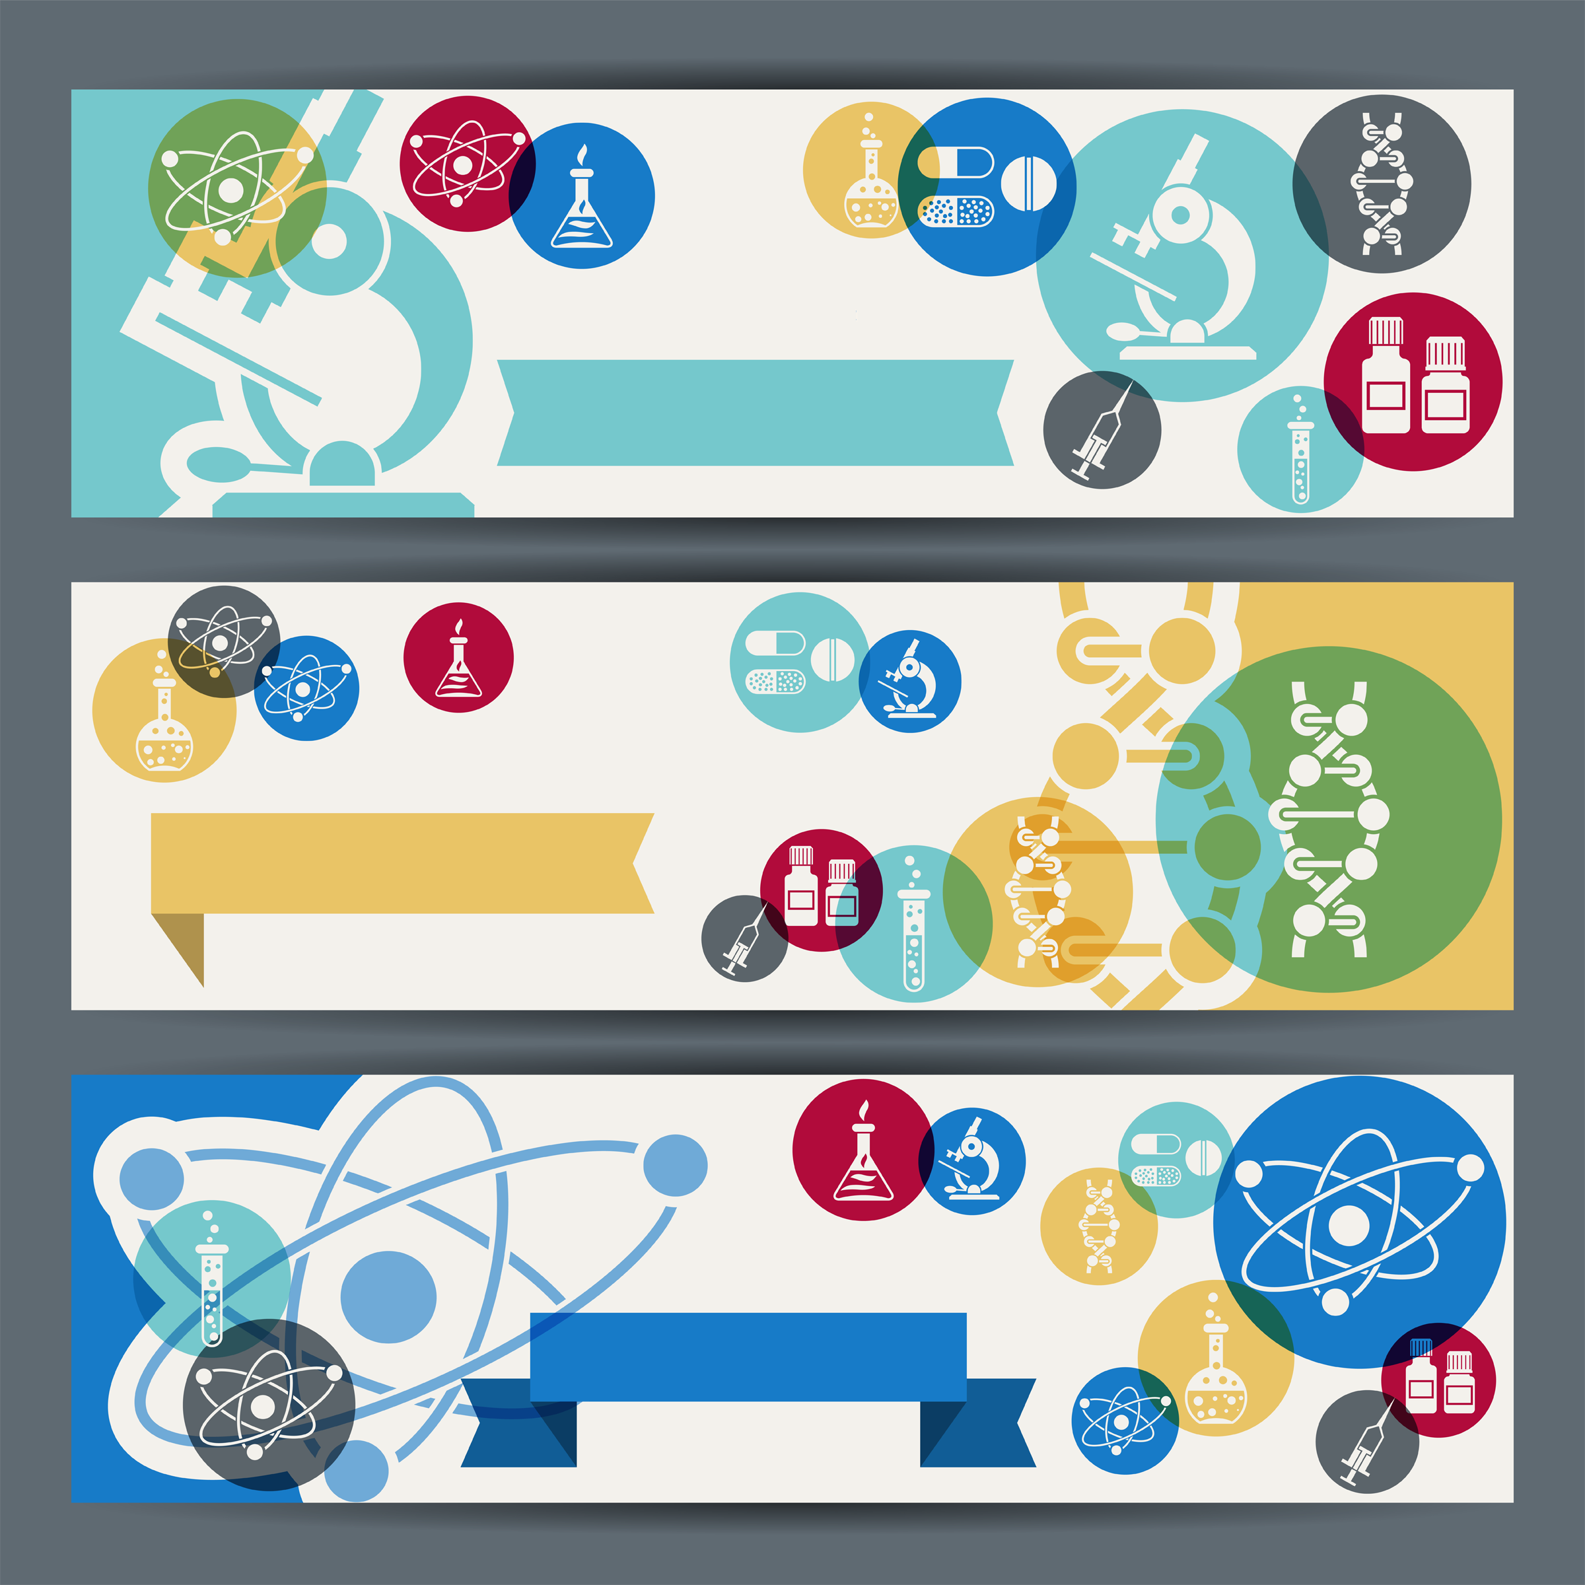
The Wheel - Advancement Ceremony
Personnel: Asst Cubmaster (ACM), Cubmaster (CM)
ACM: While pushing a wheelbarrow decorated in blue and gold and, optionally, dressed as a caveman says, “Hey you guys! Look what I invented!”
CM: “What are you going to do with it?”
ACM: “Well, uh, I don’t know, but it sure is fun and easy to push around!”
CM: “Hey I’ve got an idea. Will the parents of (new Cub Scout) and their Den Leader please come forward? Great! Parents this is (Den Leader’s Name) who will be working with your Cub Scout. Will you please stand close together in a row.
ACM brings in new Cub Scout in the wheel invention.
CM: “Thank you, now push him/her behind this line of people and I will invent a Cub Scout. (While Cub Scout is behind the row of parent the Den leader, CM and ACM put the Cub Scout in a uniform and neckerchief. When they Cub Scout appears, they are now a Cub Scout.)
CM: “Using this wheel invention, I have invented a Cub Scout.” (CM then welcomes Cub Scout to the Pack and awards Bobcat badge, if earned.)
Other rank advancements could be done the same way. While behind the line of people neckerchiefs are exchanged.
Other awards - Adventure badges, etc. could be awarded from the wheelbarrow.
Light Through the Ages
Props: Artificial campfire, kerosene lantern, shallow dish with wick and oil, regular electric lamp, candle in self-contained holder
Setting: Items on separate small tables in front of room, place awards at each station.
Cubmaster: Cub Scouting is a way of life. Let’s compare Cub Scouting with “artificial light” a good representation of the product of many geniuses. (Lights out. Turn on artificial campfire.)
When man discovered fire, he also discovered lighting. His campfire and burning knots were his first artificial light. In Cub Scouting the first light is LION. (Lights wick in dish.)
Light progresses and the Cub Scout progresses. Someone discovered that a rag in animal fat makes a better and more lasting light. Our Cub Scout becomes a TIGER and the lasting light compares with the Adventures they can earn. (Light the candle.)
Lights are getting bigger and better. Our Cub Scout is growing. We can mold animal fat around a string and get a better light. We can mold a Cub Scout and get a WOLF. (Light the kerosene lantern)
Petroleum was discovered in this country, and the kerosene lamp was developed. Now we have a better light and BEAR. (Light the electric lamp)
Thomas Edison put two wires in a vacuum tube and watched them glow in light. Our lights last much longer as our WEBELOS SCOUTS are prepared to become Scouts in troops.
At this point, turn on room lights and the actual awards are presented by calling each group of Cub Scouts and their parents forward to the appropriate table. Cub Scouts and parents may remain standing behind each table until all awards are presented.
Cubmaster: Any genius will tell you that they are absolutely useless without a greater power. We, as parents and leaders for these Cub Scouts, are a guiding light toward the great power that lies in darkness in their minds. We congratulate these Scouts for coming out of the darkness and growing brighter at each Scouting function. As they grow, so does the world.
Puzzling Advancement
Materials: A large piece of cardboard with a picture of a Cub Scout, cut out in a jig-saw style.
Cubmaster starts with “This evening we have several Cub Scouts who have completed the puzzle of achievements and electives so they may advance in rank.”
Will Tiger _____ (name of Tiger) and their parents come forward? (Give each a piece of the large puzzle.
Continue in the same way for the Bobcats, Wolfs, Bears, and Webelos, giving everyone a piece of the jig-saw puzzle.
After all the awards are presented, have the Cub Scouts and parents put the jig-saw puzzle together)
End by saying - By working together we can fit all the pieces of the Cub Scout puzzle together to make a complete picture of Cub Scouting and the youth of America.

LEADER RECOGNITION
& INSTALLATION

Here’s to the Scouters’ Spouses
Obtain Scouter's Husband awards (#33765) and Scouter's Wife Awards (33766) from National Supply (www.scoutstuff.org) or your local National Shop.
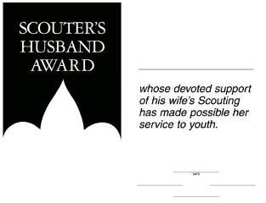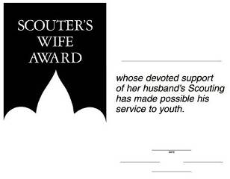
Fill In the information and sign them.
Then at a Pack Meeting (Blue & Gold?) call them forward, read Here’s to the Scouters’ Spouses and present the certificates.

Here’s to the Scouters’ Spouses
By Carol Shaw Lord
You quietly sit
While we threaten to quit
And encourage us to keep on a tryin’.
Without you being strong
We wouldn’t last long
You’re the one’s we always rely on.
You listen (without squawks)
While we practice our talks
While we’re gone you pick up the slack.
You do our share of chores,
And butler the doors,
And help keep us on the right track.
Here’s to our spouses
Who care for our houses,
That’s great help we could never hire.
Why, you hardly even mutter
While the house fills with clutter
As the Scouting stuff piles ever higher.
For all your warm greetings,
When we come from our meetings,
And helping us out in a crunch,
For manning the phone,
And your struggles alone,
We say to you all, thanks a bunch!

SONGS

Cub Scout Inventor
Tune: Whistle While You Work
Cub Scouts whistle while they work, (Whistle)
They pitch right in and laugh and grin
And they whistle while they work.
Cub Scouts hum a merry tune! (Hum)
They hum all day to work and play,.
They hum a merry tune!
Now take these genius kits,
A sack of scraps and gunk,
With paint and glue and nails, a few,
Turn them into priceless junk.
Cub Scouts whistle while they work, (Whistle)
They do their bit, they never quit,
Cub Scouts whistle while they work.

Genius At Work
Tune: Down By the Station
Out in a workshop (1)
Early in the morning (2)
See the brainy Cub Scouts (3)
Busily at work (1)
Building a computer (1)
Watch them turn the knobs (4)
Buzz, buzz, flash, flash (5)
Does not compute! (6)
Actions:
- Pound fist of right hand on left hand, as if hammering.
- Yawn and stretch.
- Point to head to show brains.
- Cup right hand and turn in front of body, as if turning knobs.
- Hold hands over ears while blinking eyes fast.
- Hold hand on head as if head hurts with
an “oh, no” look on face

Whoops, You’re A Genius
Tune: Pop Goes the Weasel or
All Around The Mullberry Bush
A block of wood, a piece of wire,
or junk that seems the seediest,
just put it all together now,
Whoops, you’re a genius.
You never know the size or shape,
From biggest to the teeniest,
But put it all together now,
Whoops, you’re a genius!

RUN-ONS

WHAT WATT?
Shopper: Have you any four-volt, two-watt bulbs?
Clerk: For what?
Shopper: No, four-volt, two-watt.
Clerk: Two what?
Shopper: Yes!
Clerk: No.

Teacher: What is the formula for water?
Jimmy: H-I-J-K-L-M-N-O.
Teacher: That’s not the formula I gave you.
Jimmy: You said H to O.
Moby: Have you ever seen a fish cry?
Dick: No, But I’ve ‘seen a whale blubber.

JOKES & RIDDLES
- Why did Benjamin Franklin discover electricity?
He couldn’t use his electric blanket without it.
- How surprised was Benjamin Franklin when lightening hit the key on his kite. He found it shocking.
- Why does lightening strike people? It doesn’t know how to conduct itself.
- Did you hear about the mad scientist who crossed a carrier pigeon with a woodpecker? When the pigeon delivers the message he can knock on the door.
- He also crossed a turkey with a centipede.
On Thanksgiving, everybody gets a drumstick

Q: Why does a chicken lay an egg? A: If she dropped it, it would break.
Q: Why are playing cards like wolves? A: They both come in packs.
Q: What has one foot on each side and another foot in the middle? A: A yard stick.
Q: What can you hold without touching it? A: Your breath.
Q: Why is your heart-like a policeman? A: If follows a regular beat.
Q: How do you write to a fish? A: Just drop him a line.

SKITS

The Robot Inventors
Characters: 6 Scientists in lab jackets (white shirts, collars turned inside out, put on backwards), 7th Scientist is dressed in the same manner and wears a top hat, Cub Scout dressed in cardboard robot costume
Setting: Table, covered with old sheet reaching to the floor in front. Fishbowl or other round glass bowl, test tubes, flasks, etc. are on the table. One of the six is reading a book plainly marked “HOW TO INVENT A ROBOT” while another looks over their shoulder. Another is stirring in a large bowl with a large wooden or cardboard spoon. Scientist #7 is offstage. Cardboard robot is hidden behind table.
SCIENTIST 1: It doesn’t seem to be working.
SCIENTIST 2: I can’t understand it.
(Scientist #7 enters from stage left carrying top hat)
SCIENTIST 7: I’ve got it! I’ve got it! A friend of mine just told me how to do it. (He places the hat on the table) You just say, “Abra-Ca-Dabra l-2-3!” reach in and....
SCIENTIST 4: Wait a minute. What did you say your friend’s name was?
SCIENTIST 7: Magisto the Magician. He says he’s pulled a robot out of a hat lots of times,
SCIENTIST 5: That’s RABBIT not ROBOT you dunce!!
(They chase Scientist 7 offstage, waving book, spoon, etc. Scientist 6 starts to join them but stops and looks at hat)
SCIENTIST 6: (shrugging shoulders) It just might work! Abra-ca-dabra l-2-3! (He takes hold of hat with left hand, tips it towards himself at edge of table, pretends to reach in hat, but really reached behind table and pulls up the robot who has been hidden) hey, you guys! It worked! Now I’ll just push this button....(pretends to push button on front of robot) ROBOT DROPS TO ALL FOURS, HOPS OFFSTAGE SHOWING A BIG FLUFFY BUNNY TAIL BOBBING AT BACK)
The Invention
Cast: 4 or more Cub Scouts
Scene: Cub Scout 1 is sitting on a chair (bed). Toys and clothes are scattered all over the “room”. They are deep in thought. Several of their friends have come over to see him....friends enter.
ALL: Hi! What are you doing?
# 1: Just thinking.
# 2: Thinking about what?
# 1: My invention,
# 3: Are you inventing something
# 1: Sure! I want to be famous like Alexander Graham Bell or Thomas Edison.
# 4: What are you going to make? Maybe we could help.
# 1: Really? Do you all want to help?
ALL: SURE!
# 1: OK. (stands up) First of all, I need a box. There’s one in my closet. (CUB SCOUT 2 goes off stage to get a box)
Then I need 2 toy airplanes, (CUB SCOUT 3 picks them up)
And I need some kite string. (CUB SCOUT 4 gets it)
(Continue with this until all the toys have been picked up by the Cub Scouts.)
Last I need some rags. We can use my clothes for that. (They pick up the clothes)
# 1: (Looks around the “ROOM”). Well, that just about takes care of it.
# 2: Takes care of what?
# 1: My invention! I just invented a way to get my room cleaned before my mom gets home!
Inventions
Narrator:
The horizon of our world
Might never have been widened,
If men before us hadn’t tried
To answer questions that -mystified.
Their greatness we do not dispute,
But how they did it, we refute.
The legends have become so great,
We want to set the record straight!
BEN FRANKLIN: (carries kite and key)
Ben Franklin had to find ‘lectricity;
He was picked up one night for insanity,
It was all he could do to explain
Why he liked to fly kites out in the rain.
ALEXANDER G. BELL: (carries phone),
He invented the phone, as history books tell;
He was a man named Alexander Bell,
But the reason he did...the books are hazy;
His wife loved to talk...nearly drove him crazy!!
TOM EDISON: (carries lightbulb)
Young Tom Edison, we’ll admit,
Gets a lot of credit and deserves all of it.
But it’s little known that he invented light
‘Cause he tripped-on the bed one dark, dark night!! –
WRIGHT BROTHERS: (carries toy airplane)
The Wright Brothers got the first plane to go,
It wasn’t their hang-up if you want to know;
It hurt their pride when they heard a lady talk and say:
“Who ever heard of Kitty Hawk?”
ALL: So, with invention, you can see,
That although the Mother of Necessity,
It all would have been just a lot of bother,
If Accident hadn’t been the Father!

CLOSING CEREMONIES

Just Imagine
Can be done by the Cubmaster or four Scouts.
- Rudyard Kipling, the famous English author, who wrote the story of the Jungle Book, wrote a little poem. It begins like this:
- I keep six honest serving men
They taught me all I knew;
Their names are What and Why and When
And How and Where and Who.
- If you make these six your servants imagine the things you could do! Just imagine for a minute that a little green man from outer space lands in your backyard. Now the alien wants to know how the picture gets in the television. What causes thunder? Why does night come? Where did your parents live before you were born? Could you answer his questions?
- From this moment on you can decide to be an investigator. Ask questions about everything that you have ever wondered about. What are clouds made of? Are all of the lights in the night sky stars? How would I take care of myself if my parents were gone all day? What can I make by myself? How old are my pets compared to me? What kind of insects live in the field behind my house? How do they protect themselves? What is the street made of? Why is it cooler in the mountains than down in the valley? If the mountains are closer to the sun shouldn’t it be hotter? If your parents, teachers and leaders can’t give you the answers, then look to books and computers. Just imagine!
- Look around and you will find hundreds of things waiting to be investigated. You’ve only one life and future...make the best of both!
Kitchen Chemistry
We’ve all seen a pot of water boiling on the stove. We’ve seen the water vapor (which many of us mistakenly call steam) rising above the pan. If we allow the process to continue, we see that eventually there’s no more water left. The H2O, in its gaseous state, becomes a part of the atmosphere. In a closed experiment, that water vapor would be trapped in tubes and recaptured. We don’t have that sort of equipment in the ordinary kitchen where some of our experiments took place this month.
We are gathered here together because of one common bond, the Cub Scouts in our pack. They have graduated on to new, challenging programs as of today. Our challenge, as parents and family members, is to capture their enthusiasm and energy, to direct it in a positive manner. They need our input, providing them with the proper direction, just like the chemical lab captures and redirects the water vapor in an experiment. That’s a big part of what the Scouting program is all about.

Closing Prayer
Ask the Cub Scouts and their families to form a large circle and hold hands. The Cubmaster then reads the following prayer that was broadcasted to earth by Astronaut Frank Borman, while on a moon orbiting mission.
“Give us, oh God, the vision which can see thy love in the world in spite of human failure. Give us the faith to trust they goodness in spite of our ignorance and weakness. Give us the knowledge that we may continue to pray with understanding in our hearts, and show us what each one of us can do to set forward the coming of universal peace.”
Rope Living Circle
Equipment: A two or three-foot length of rope or heavy cord for each Cub Scout.
We have seen tonight that we are all geniuses in our own right. It makes you might proud, doesn’t it. And we all should be proud of our accomplishments and abilities. We should never forget though that we all depend on other people and our greatness does not come out till we can be great with and for other people.
Would all the Cub Scouts come and make a circle. Take a piece of rope, each of you, and tie it to the tope of the person on your left with a square knot. Joining with other people makes you a better person.
Hold your rope with your left hand and make the Cub Scout sign with your right hand and let’s say the Promise together and pledge ourselves again to the ideals of Cub Scouting.

Professor Plop Closing
Baltimore Area Council
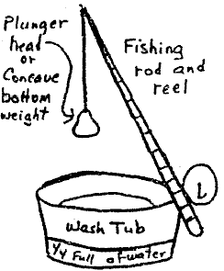
Cubmaster: Now we’ll check with Professor Plop one last time. Well, Professor, did you ever get it together?
Professor: I sure did. I made it!
Cubmaster: We can hardly wait to see how it works.
Professor: I will demonstrate this wonderful invention for you.
- See drawing, Professor cranks his reel,
- Drops the plunger into a tub of water and it goes ‘plop’.
- He then reaches into the tub of water, pulls out a piece of cloth,
- He wrings it out, shakes it open.
- It reads: “The End”

CUBMASTER MINUTES

Cubmaster Minute
We have seen and heard about a lot of inventions tonight both serious and humorous, Having participated in this Pack Meeting I am sure you can all understand Thomas Edison assertion that inventions are 5% inspiration and 95% perspiration. Unfortunately, we are not yet done perspiring yet. That is of course unless one of you Cub Scouts has invented an Automatic cleanup machine. However, if we all work together I am sure we can make quick Work of this problem and adjourn our Invention Convention.
Six Million
Today in our country there are over six million Cub Scouts and adults in Scouting. That's a good thing to know...a good thing to think about when we get to wondering about the future.
Six million, keeping a promise to “do their best,” to “help other people,” and to “respect God and country.”
Six million, following Baden-Powell's admonition “try to leave this world a little better than you found it.”
These six million can make the difference in tomorrow.
These six million WILL make the difference in the future of this country and in the future manhood around the world.

Four Closing Thoughts
One of the hardest things for anyone to do is to stick to what they know is right while their friends are coaxing them or their enemies are telling them to do the opposite. A Cub Scout does their best.
A Cub Scout does what they know; they are what they do; what they’re going to be, they’re becoming.
Do Your Best – one of the most important things to learn in life is to put forth your best effort when doing something. That is why we have the Cub Scout motto. As a member of this pack, I hope you will put forth your best effort for the good of the pack and for your own good.
Don’t Give Up – to be good at anything, you have to believe that you can do it, and then practice it until you can. There’s no easy way to become an expert. You just have to keep at it, over and over. There will be times you’ll think that you just can’t make it. But don’t give up a task because it seems hard. There are few things worth doing that are easy to do at first.

CUB GRUB

GAMES

Crossed and Uncrossed
Do NOT give away the gimmick (Leg position), make the Scouts earn it.
Players are seated in a circle. Begin the game by passing the sticks to the Cub Scout on your right saying, “I pass these crossed” or “I pass these uncrossed” depending on whether or not your legs are crossed, not the sticks (crossing and uncrossing the sticks on each hand off adds to the confusion and fun of the game) The Cub Scout receiving the sticks says, “I receive these uncrossed sticks, I pass them crossed.” Again, according to the position of their legs. On each pass, say whether the Cub Scout is right or wrong in their statement. Keep playing until all players catch on. (You may want to coach one or two Cub Scouts beforehand.)

INVENTION Scramble Relay
Write the letters INVENTION on separate pieces of paper, make two sets of them.
Divide into 2 teams. On signal the, 1st one of each team races to where the cards are all scrambled. They pick up any letter from the pile and the pencil beside it, writes any word beginning with that letter on the paper, then races back to tap the next in line. They all take turns doing this until all the letters have been used. If a Cub Scout can‘t think of a word beginning with their chosen letter, they may choose a different letter not used and write a word for that letter. However, they can’t come back and tap the next until they have written a word and the team can’t complete the relay until every letter has at least one word written on it. The first team done is declared the winning team.
The Cub Scouts have lots of fun doing this one and won’t realize they are learning the art of quick thinking, learning new words, and teamwork. To make it harder you can require 2 or 3 words on each letter. If the Cub Scouts want to play it a second time, that might be a good time to make the rules a little tougher.
Progressive Invention Kit
- This can be a combination of a craft project and game. It can be varied in many ways to suit the needs of your den. It can combine the fun of a game with teamwork, thinking fast and imagination.
- Give each person 2 or 3 scrap items without telling them what they will be doing with them. The bigger the variety, the better so that they can all pick different things.
- Divide group into 2 teams. Each team sits around a table or in a circle on the floor. Have items available to each group such as stapler, scissors, glue, tape, hammer, and nails, etc.
- On signal, player #1, combines their items in some fashion to make a project. After using all items, they then passes it to the next person, who adds all their items in some way using glue, nails, tape, staples, etc. as needed.
- This continues around the team until everybody’s items have been added and a completed project is in front of them, at the end.
- When a whistle is blown, the project is done. Then the group takes a few minutes to make a description of their project, giving it a name and tell with it does. Here’s where a Cub Scout’s imagination can create some unbelievable contraptions. The explanations will be shared and are bound to bring a lot of laughs. This could also be done in a den by pairing the Cub Scouts off to do this if you have an even number of Cub Scouts thus having more groups competing with each other. At the end of this, everybody should get a genius award of some kind for their participation.

Amazing Flying Machine (Bomb Pops)
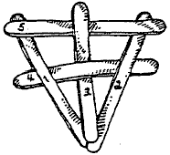
Materials: 5 Craft sticks (tongue depressors work best)
- Weave the 5 sticks together as shown.
- Fly like a Frisbee. The plane “explodes” on contact with the ground or other surfaces.
- Assemble it again, and have more fun.
Calendar Checkers
Place a calendar page on the floor. Have the Cub Scouts stand at least six feet away and take turns tossing 3 checkers onto the calendar page. When everyone has tossed their checkers, have them total up their score. The date they have landed on determines their number of points.
Secret Orders
Divide players into two teams. In turn, each player runs from the starting point to the chair, where they picks up a card, reads the “order” and then fills the order. Ex. shakes hands with every member of your team, crawls through the other Cub Scouts’ legs pretending there is a fire and smoke has filled the room, etc. The second team member then runs and reads their order.
The first team to fill all of its orders wins. The fun is in the “orders”. Be creative!
Secret Invisible Ink
Dip a clean pen into the juice of a lemon, and write your message. To make it appear, heat the paper slowly over a hot light bulb. Milk will also work in place of lemon juice.
Human Machine Company
Form into groups of 8 - 10. Each one takes on the part of the machine they are as a group. One by one the parts of the machine go together and sounds are added. Example: a car, one is the engine, another the windshield and another the trunk, etc. Use a little imagination and make up your own machines for fun.
The Mad Scientist
One player is chosen as the Mad Scientist and leaves the room. The rest of the players form a line and hold hands. Then, without letting go of their hands, the line ties itself up by crawling under the arms, through the legs, over the arms, etc. The Mad Scientist then returns and tries to untangle the line without anyone letting go of the others hands.
Paper Airplane Contest
Give each Cub Scout one sheet of paper. Have them design and make airplanes by folding the paper. No other materials may be used. Have a contest judging the planes in one or several categories. Some suggestions are: distance, loops, tricks, or landings, judging the best in each category. It is best to allow the Cub Scouts to do the judging. Everyone will be a winner!
Newspaper Ad Relay
Needed for this game are: 2 or more newspapers, folded; a pair of scissors for each newspaper; a list of ads to be cut (one list per team). Place a newspaper and a pair of scissors on a table or the floor 30 feet from the starting line. Divide players into teams (relay formation). Players run to the folded paper, unfold paper, find ad, cut out ad, refold paper and checks ad off list. Player returns to line and next player repeats process and on through the line. First team done, wins.
Genius Balloon Race
Divide your group into even teams. Set up a goal at the other side of the room. Line your teams up opposite the goal. Give the first person in the line a balloon. Tell them simply that they must go down to the goal and back carrying the balloon, give it to the next person in line, who does the same thing, on to the last player. The first team to finish with all the players is the winner. What makes this a genius race? Simple -- no one is allowed to touch the balloon with their hands! It takes a genius to figure out how to transport that balloon! One little concession; let the receiving person touch the balloon or they may never pass it from one to another,
YOUR DATA PLEASE
- Everyone sits in a circle and one player is asked to leave. While that player is out, the group chooses a noun for their data, like shoe or job, to be guessed by the absent player who is the computer operator.
- When the operator returns, they ask, “Your data please?” to anyone they choose. That person must respond with a true answer (one word adjectives are sufficient), describing the data that is theirs.
- For example, if the data (answer) is car, someone might answer, “old” or “expensive.” The operator tries to guess the data after each adjective until they guess correctly.
- The last player to name an adjective before the correct data is guessed becomes the new computer operator.

SURFING THE INTERNET
- The players may stand or sit in a circle. One player is “it” and they stand inside the circle trying to discover where the internet is connecting.
- All of the players are the internet and hold hands as one player, preferably someone standing behind “it” is designated to start the communications going. They squeeze the hand of either the person to their left or right.
- That player passes it on in any direction by squeezing another’s hand in any direction.
- “It” turns around and watches closely the faces and hands of the players in order to detect the position of the Internet connection. When they guess correctly, the player caught takes their place.

DECORATIONS

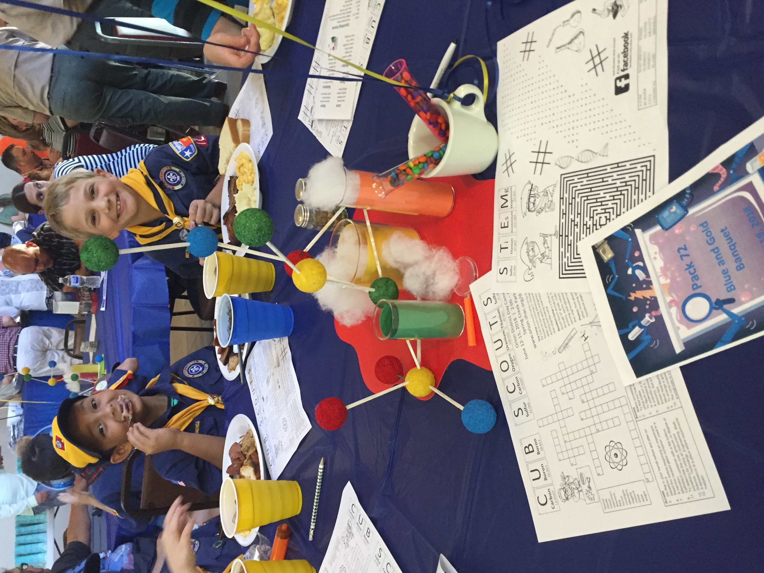

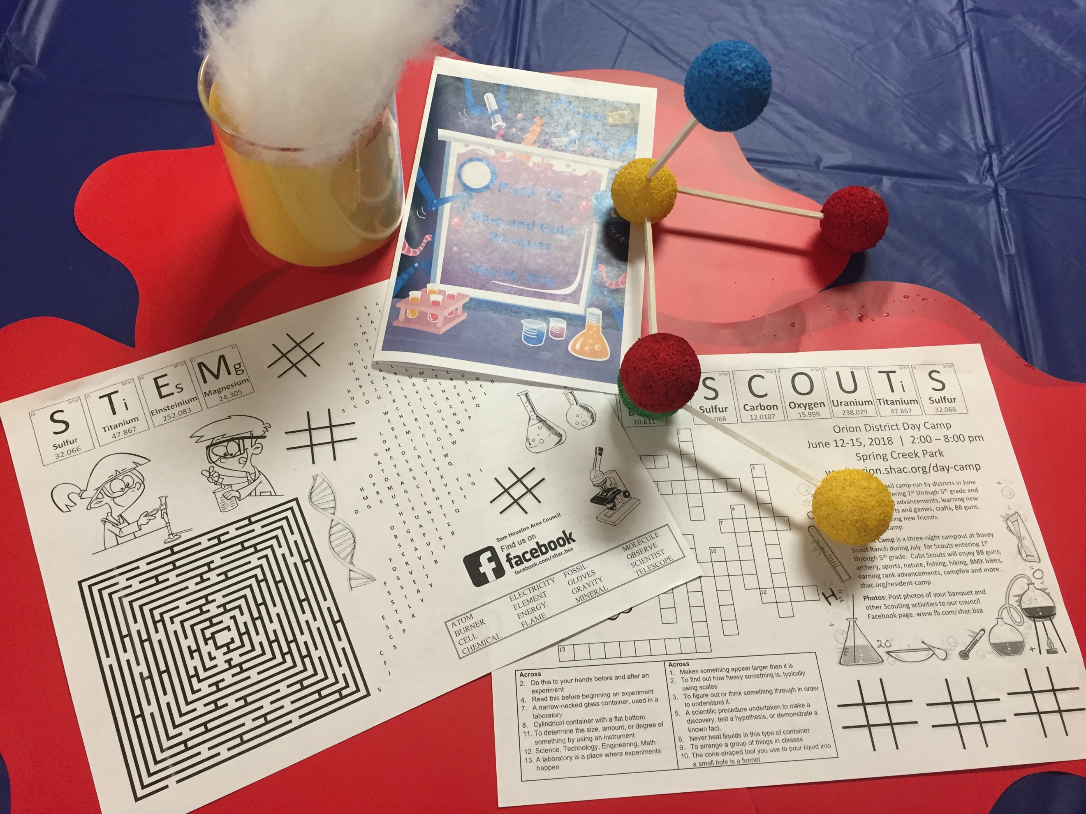

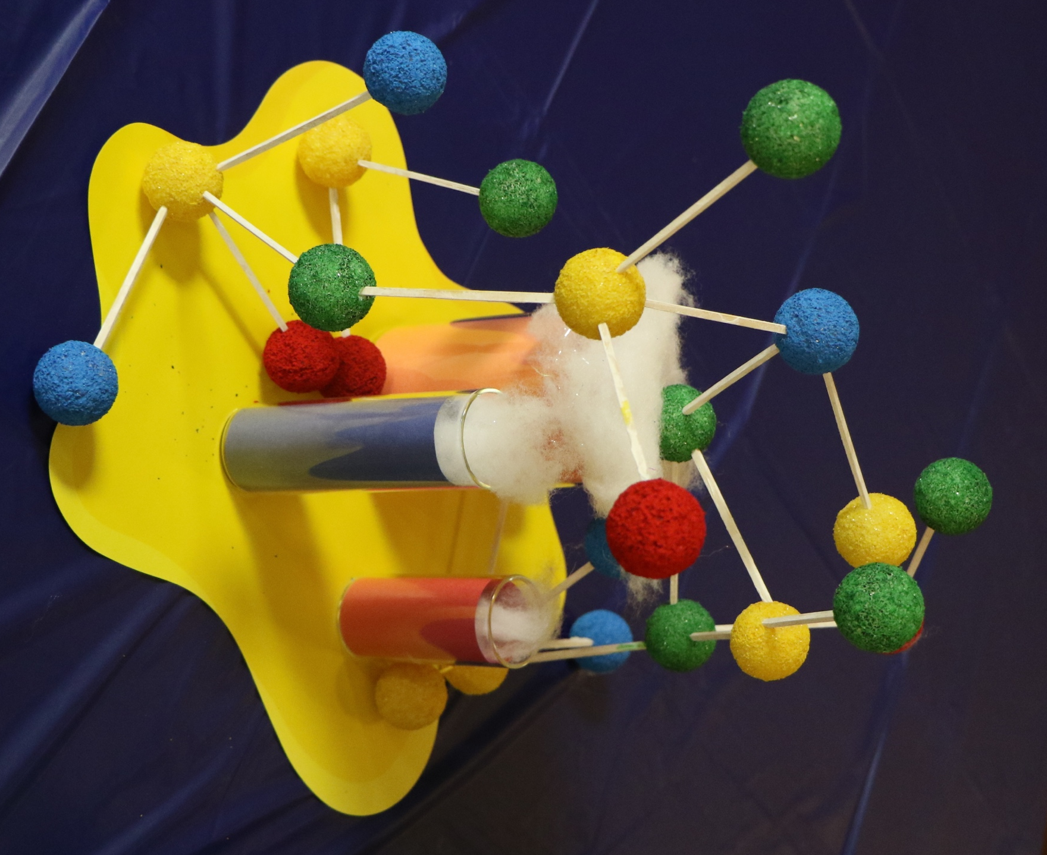

SOCIAL MEDIA POSTERS

Post a sign asking parents to tag @shac.bsa or @Sam Houston Area Council (www.facebook.com/shac.bsa), your district Facebook page (see shac.org/districts), and your unit page.

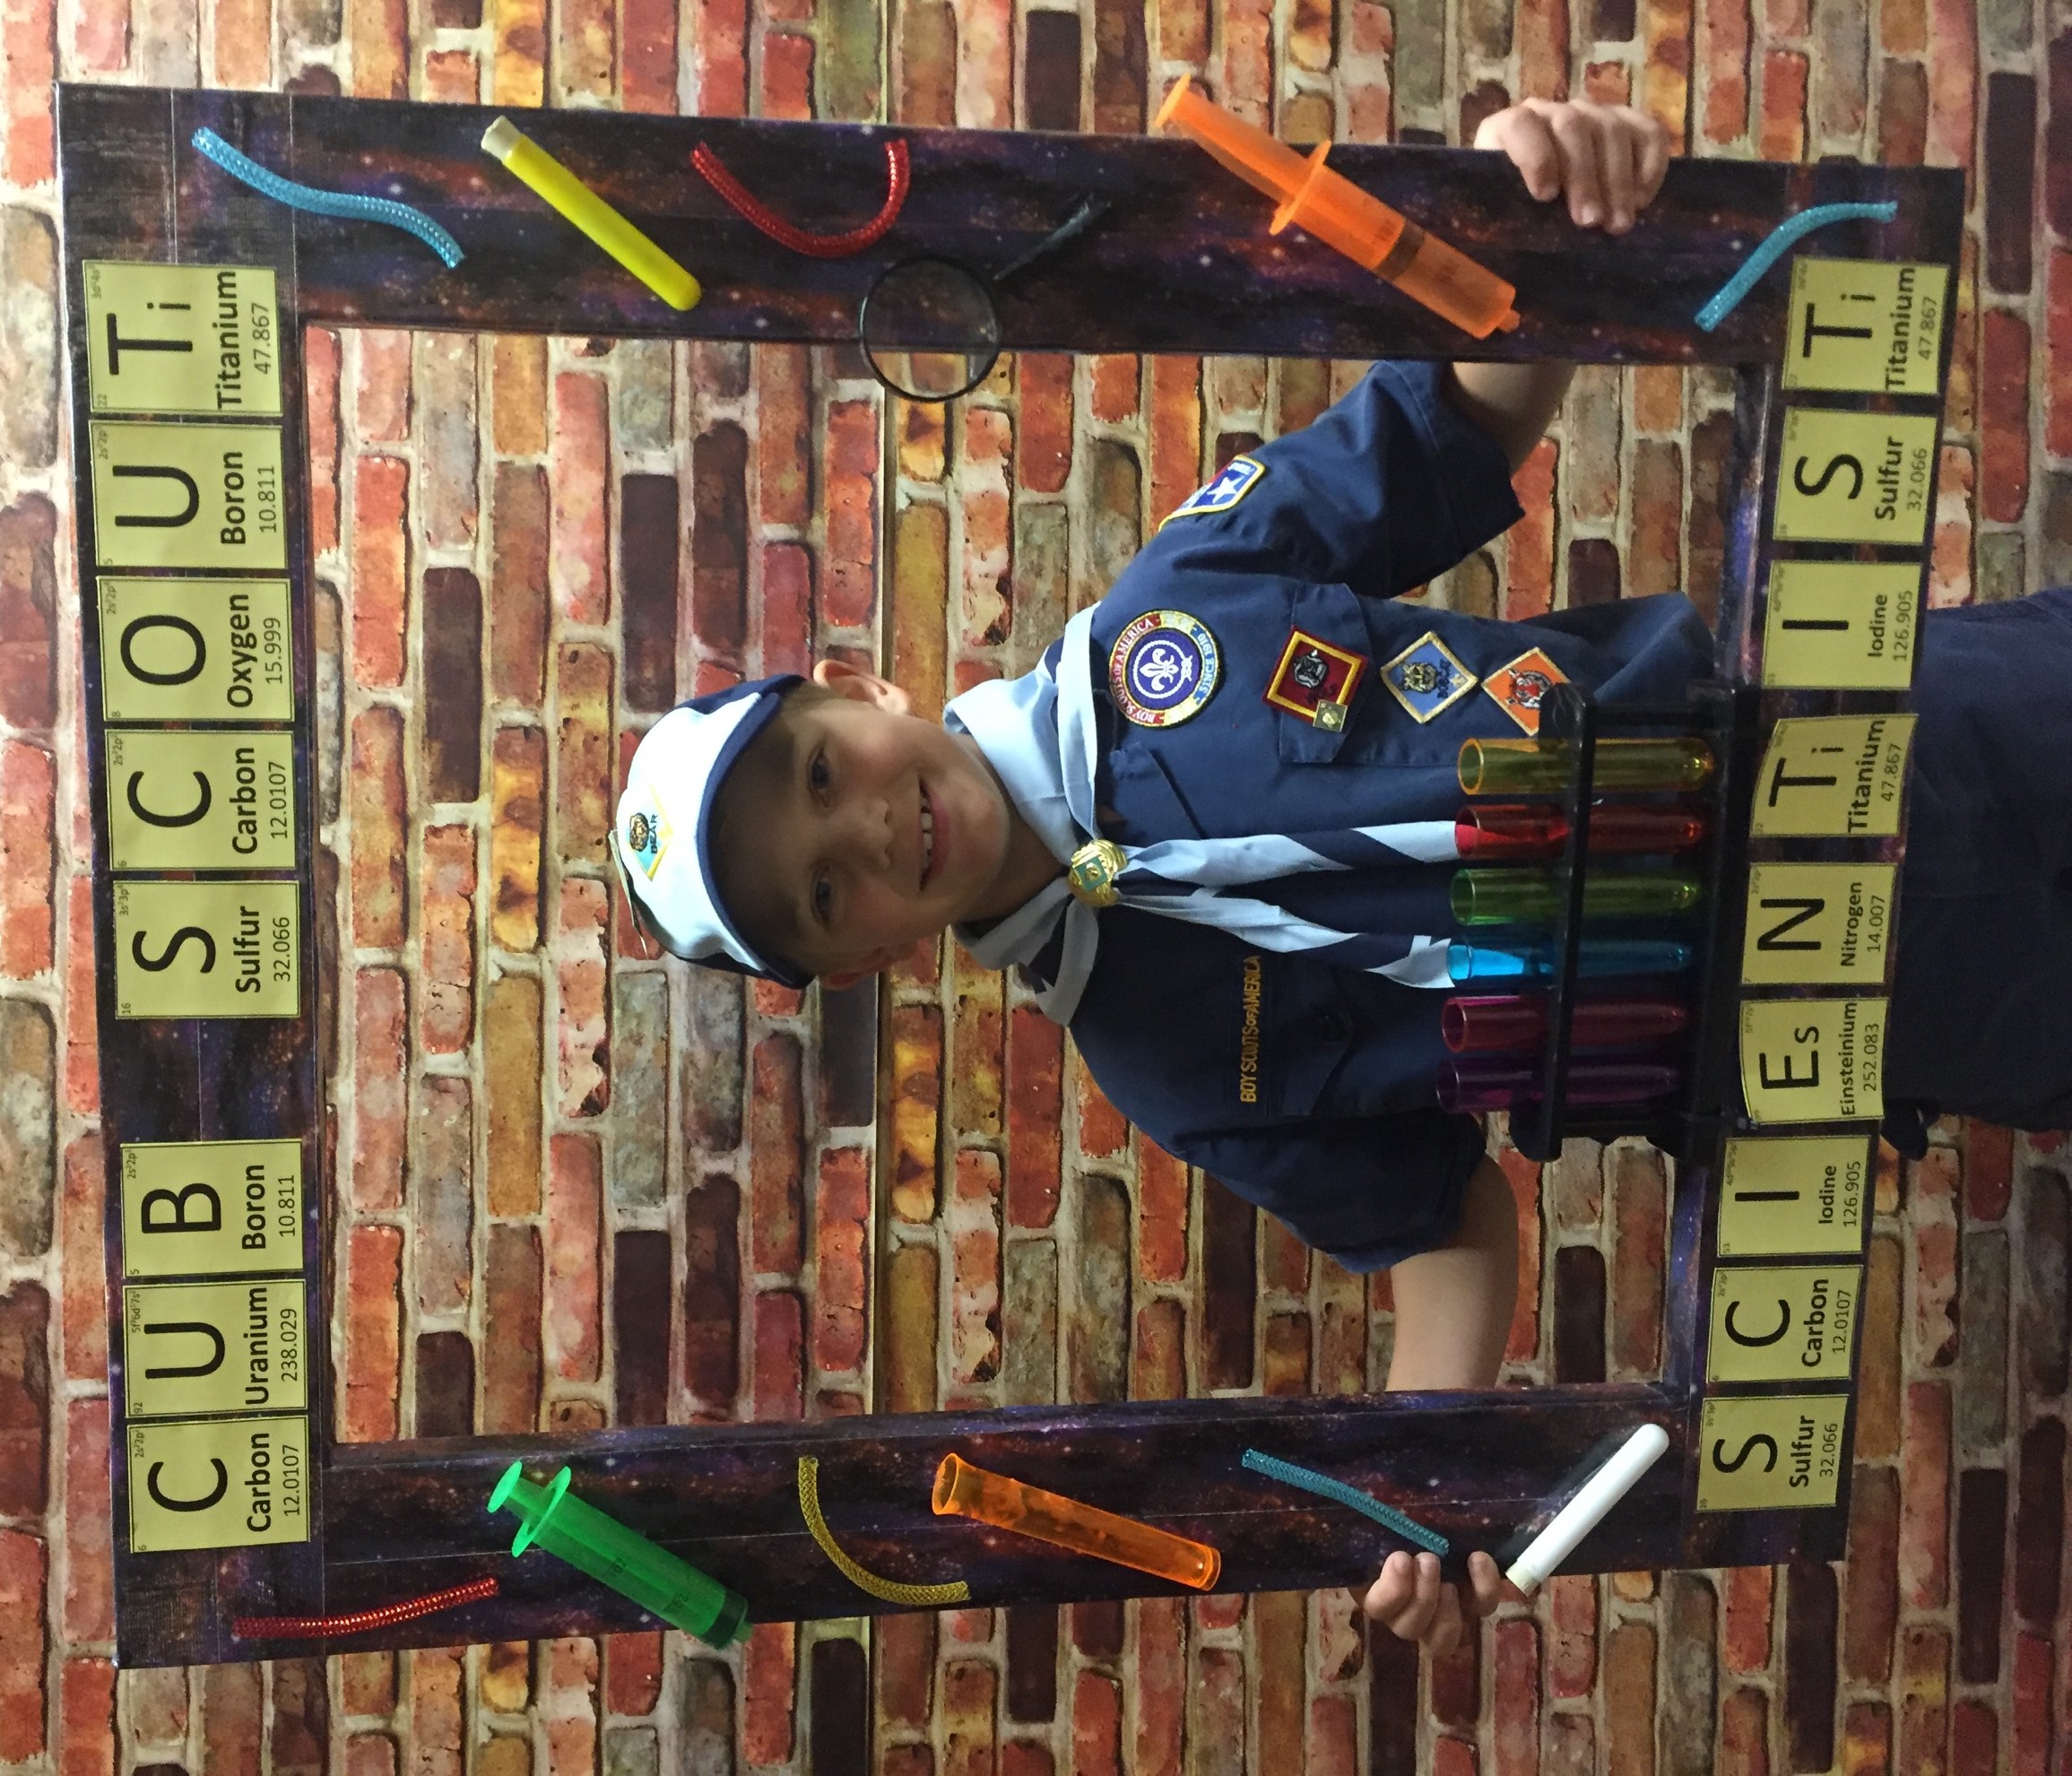

All items (photo frame, objects) were purchased from Arnie’s Warehouse in Houston, except for the letters which were printed on card stock.

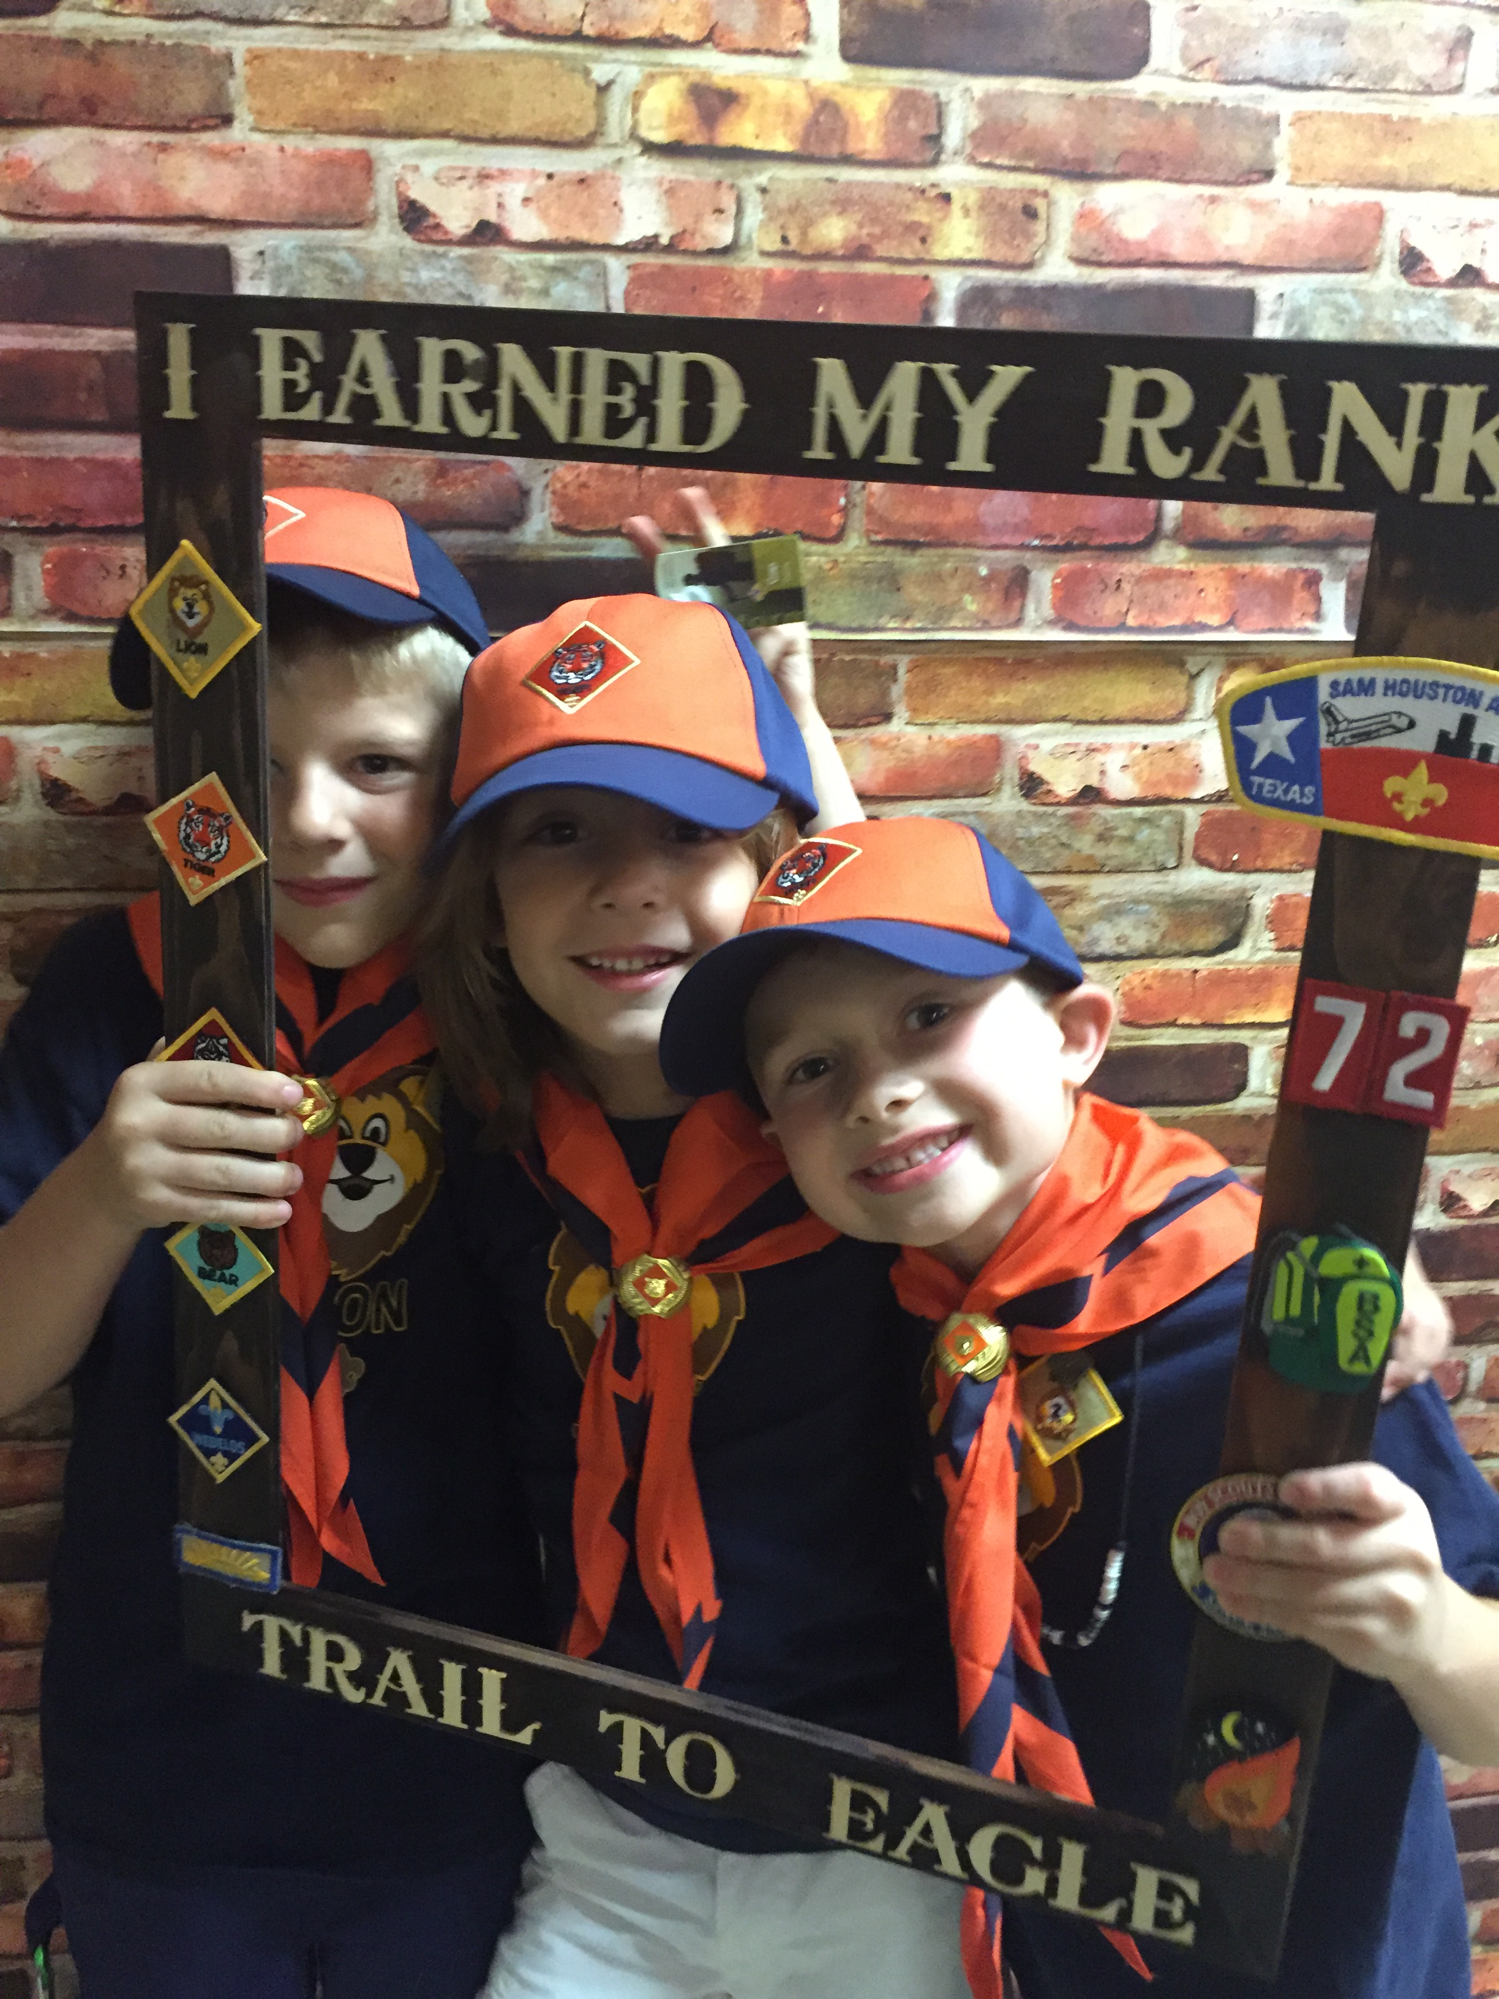

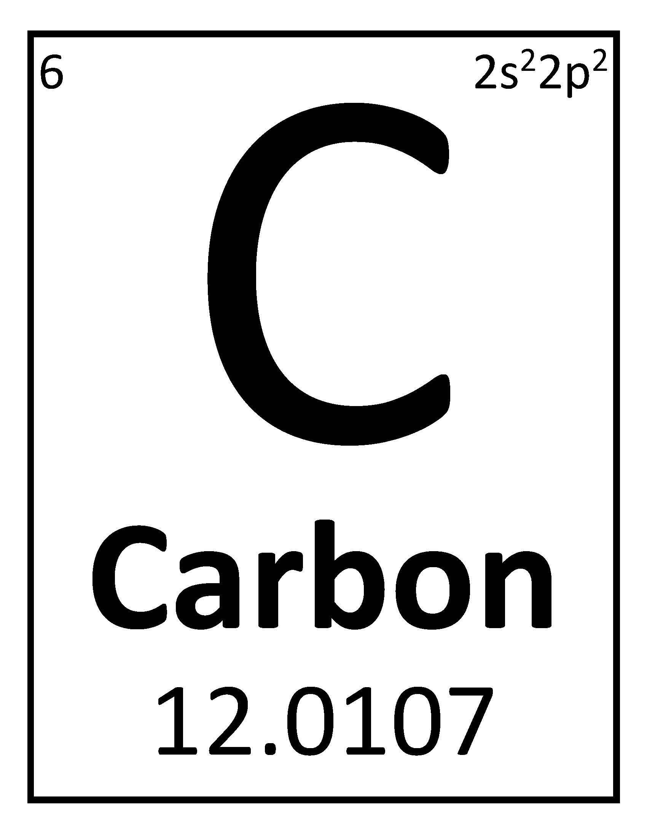
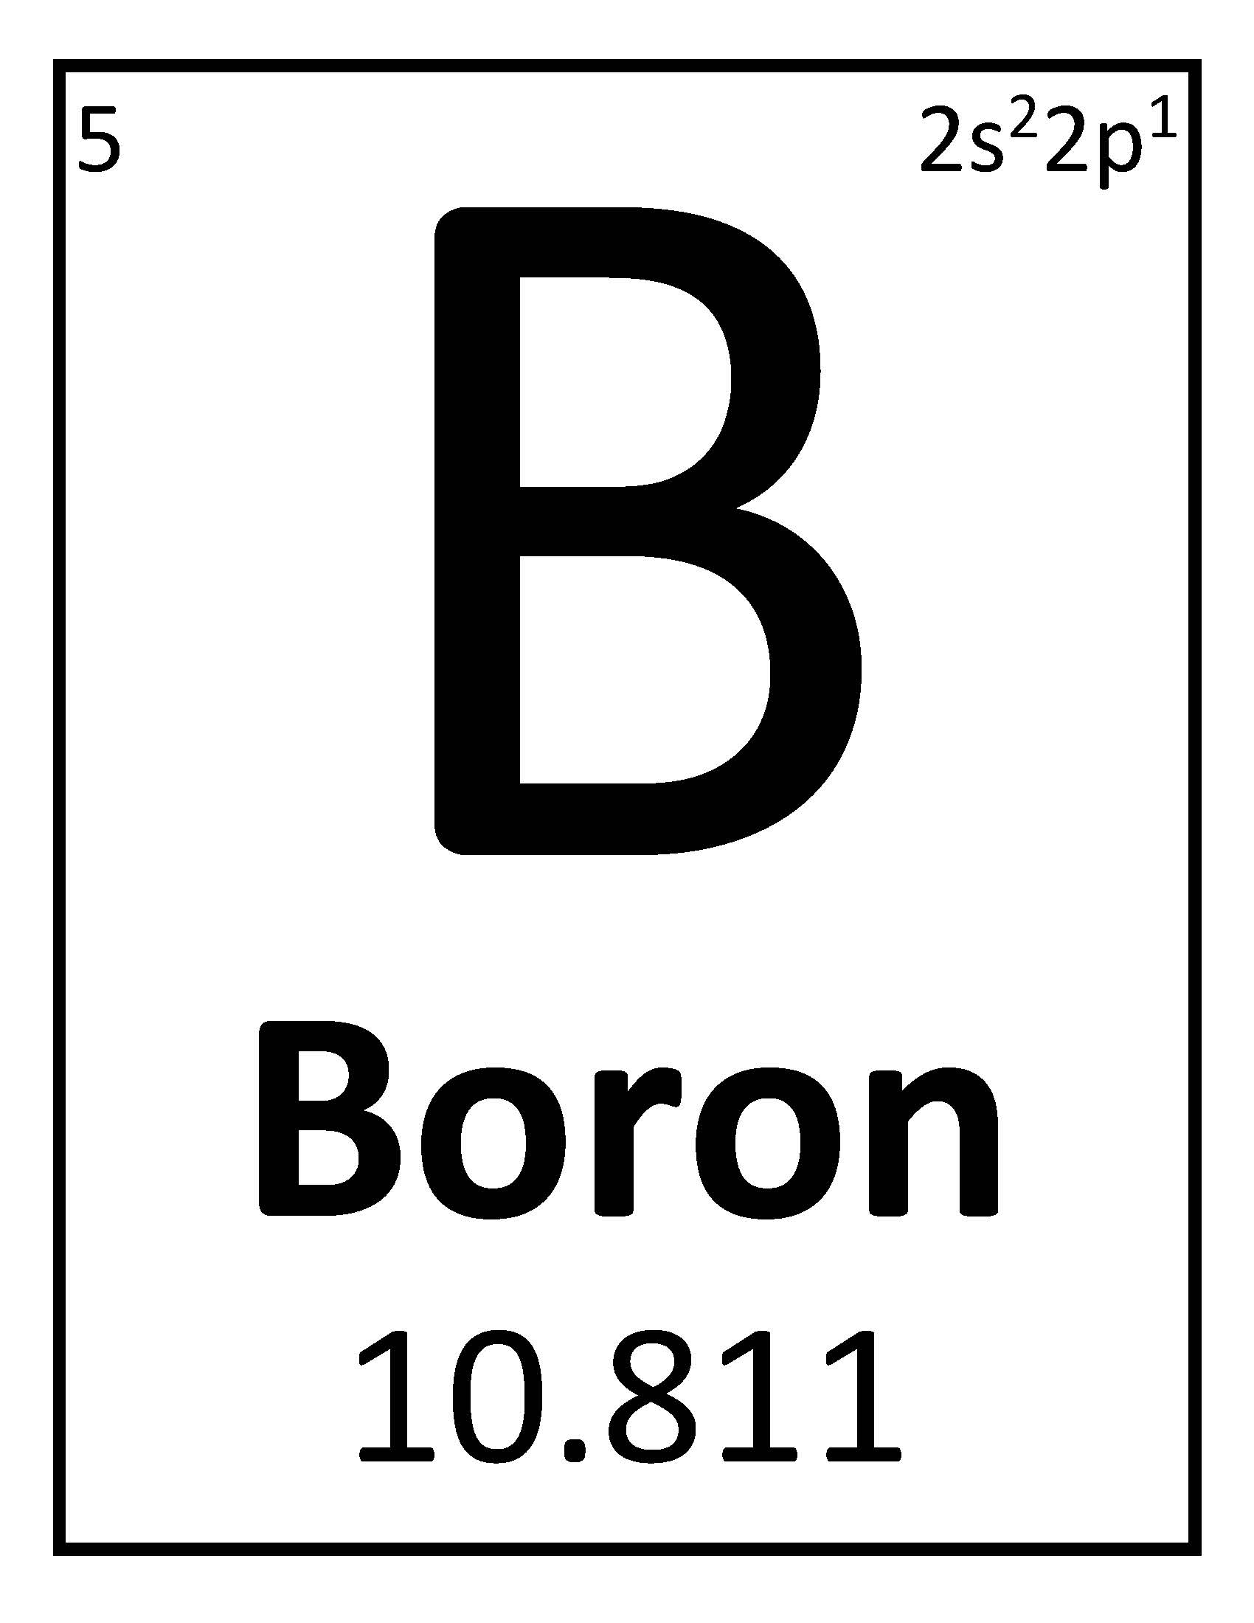
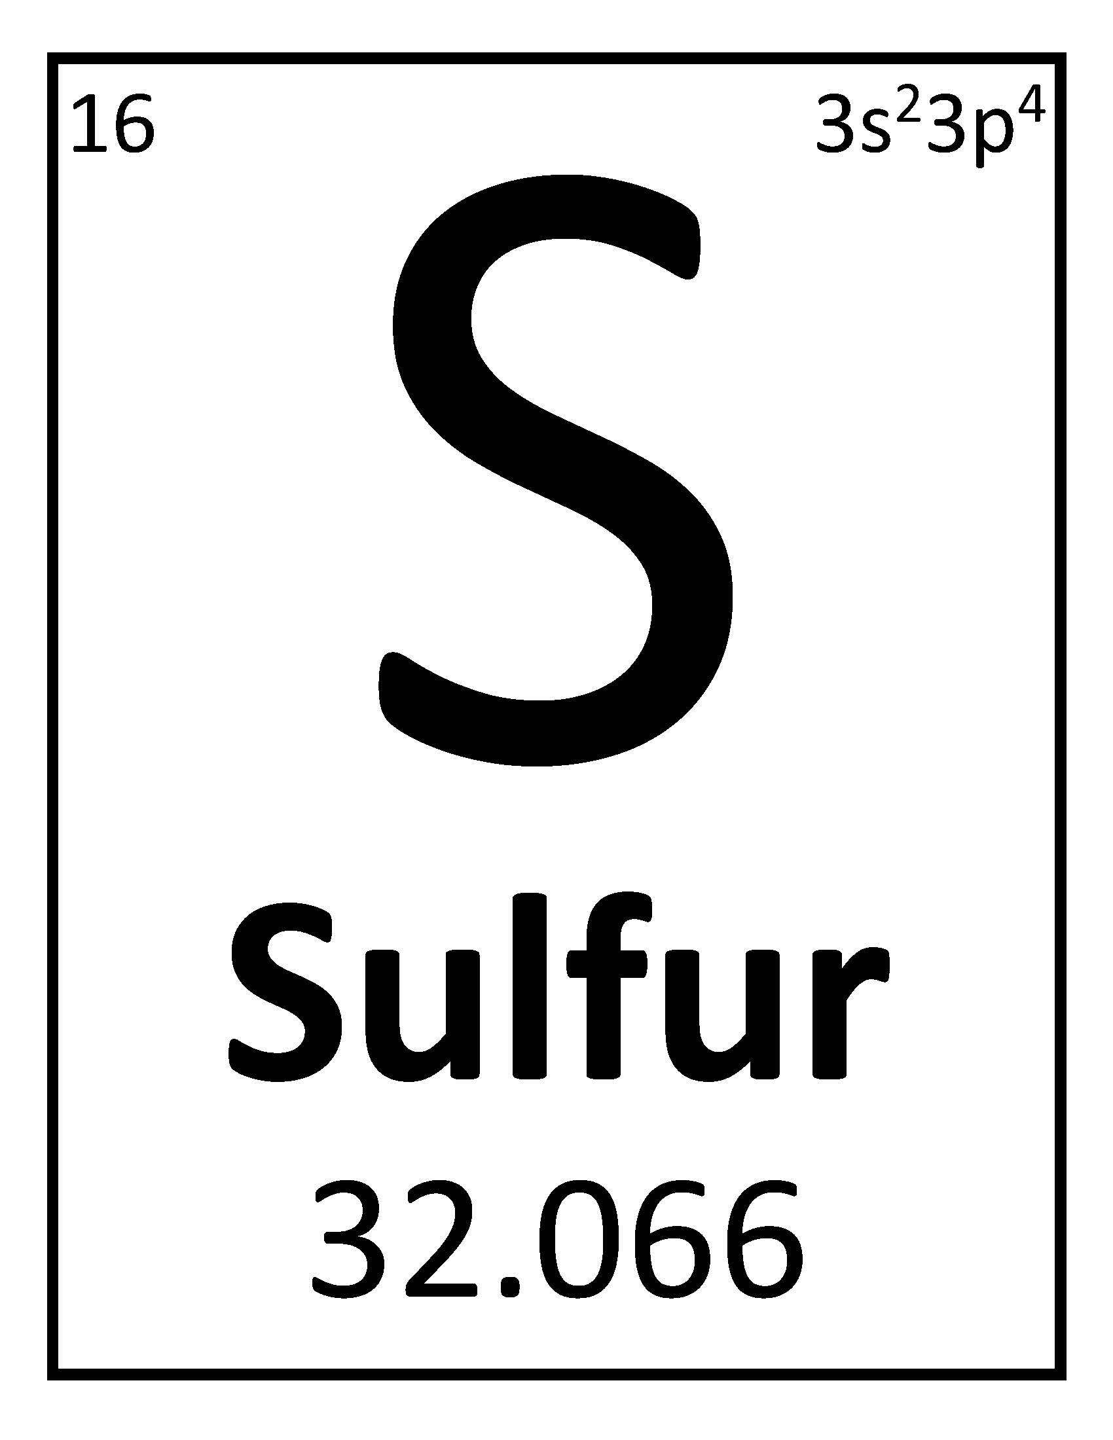
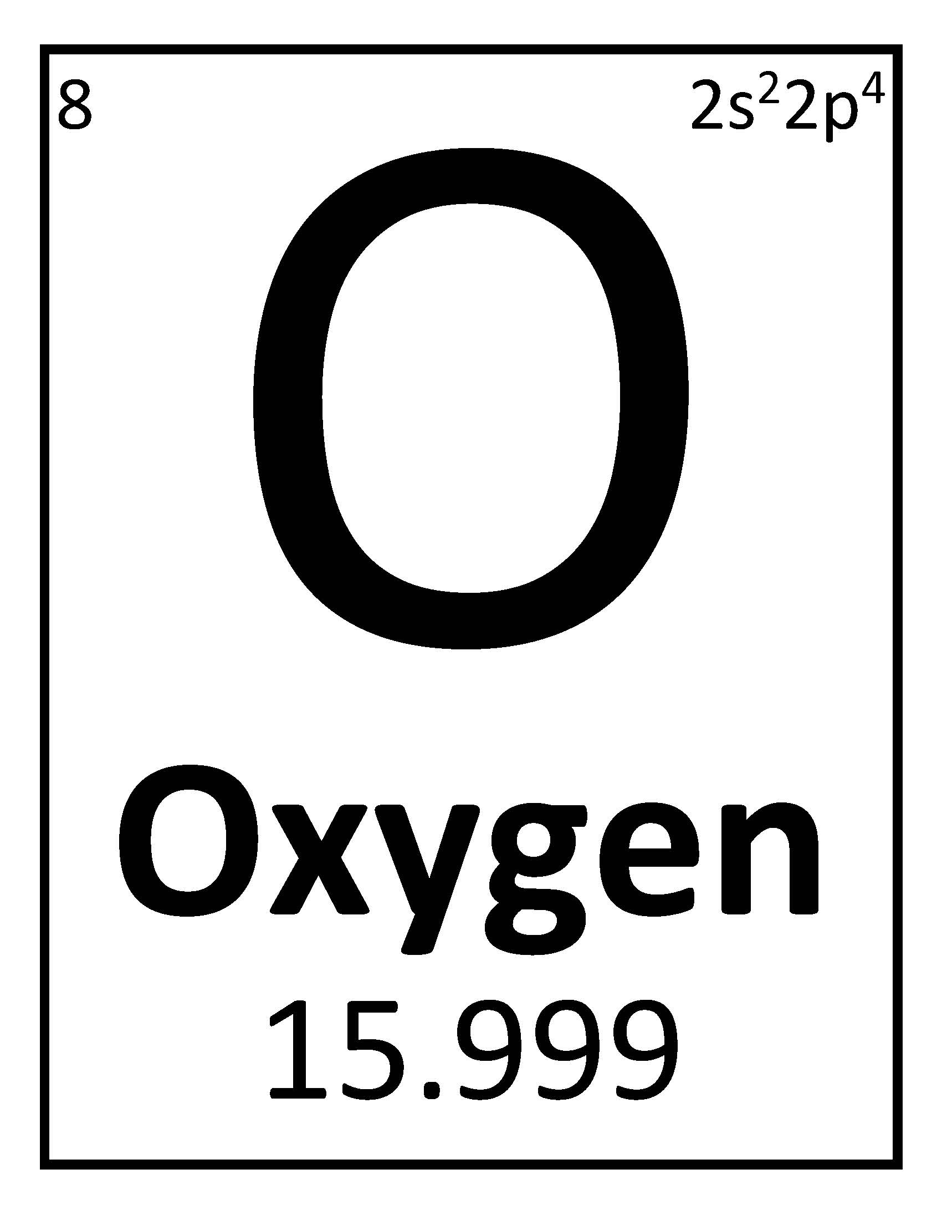
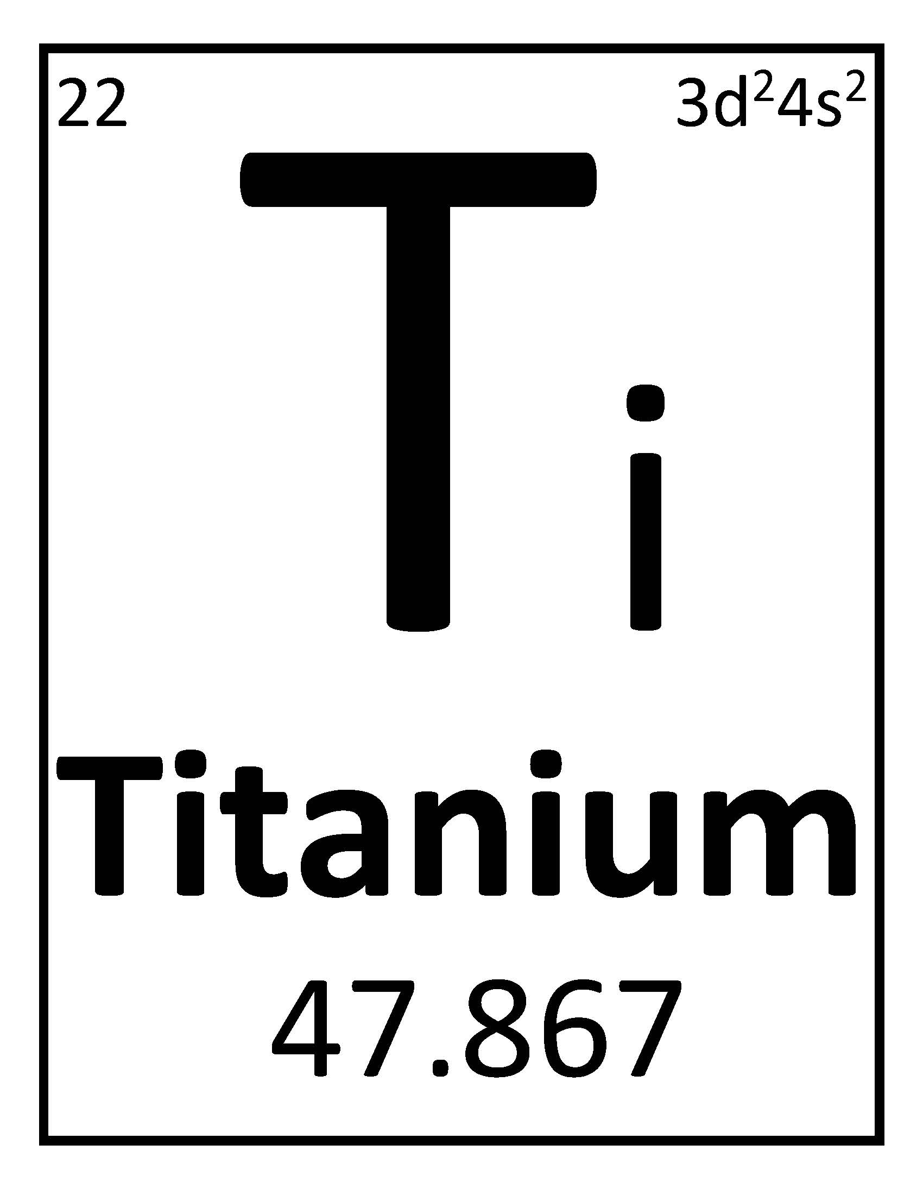
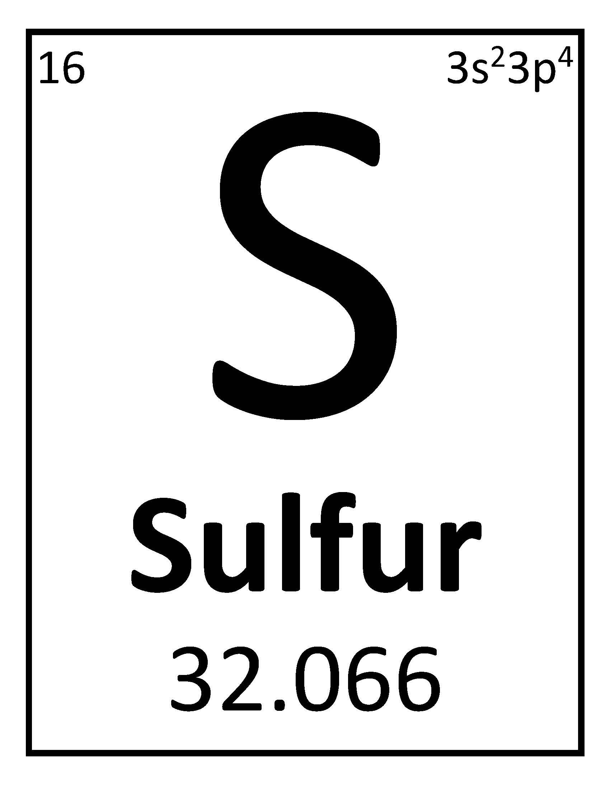
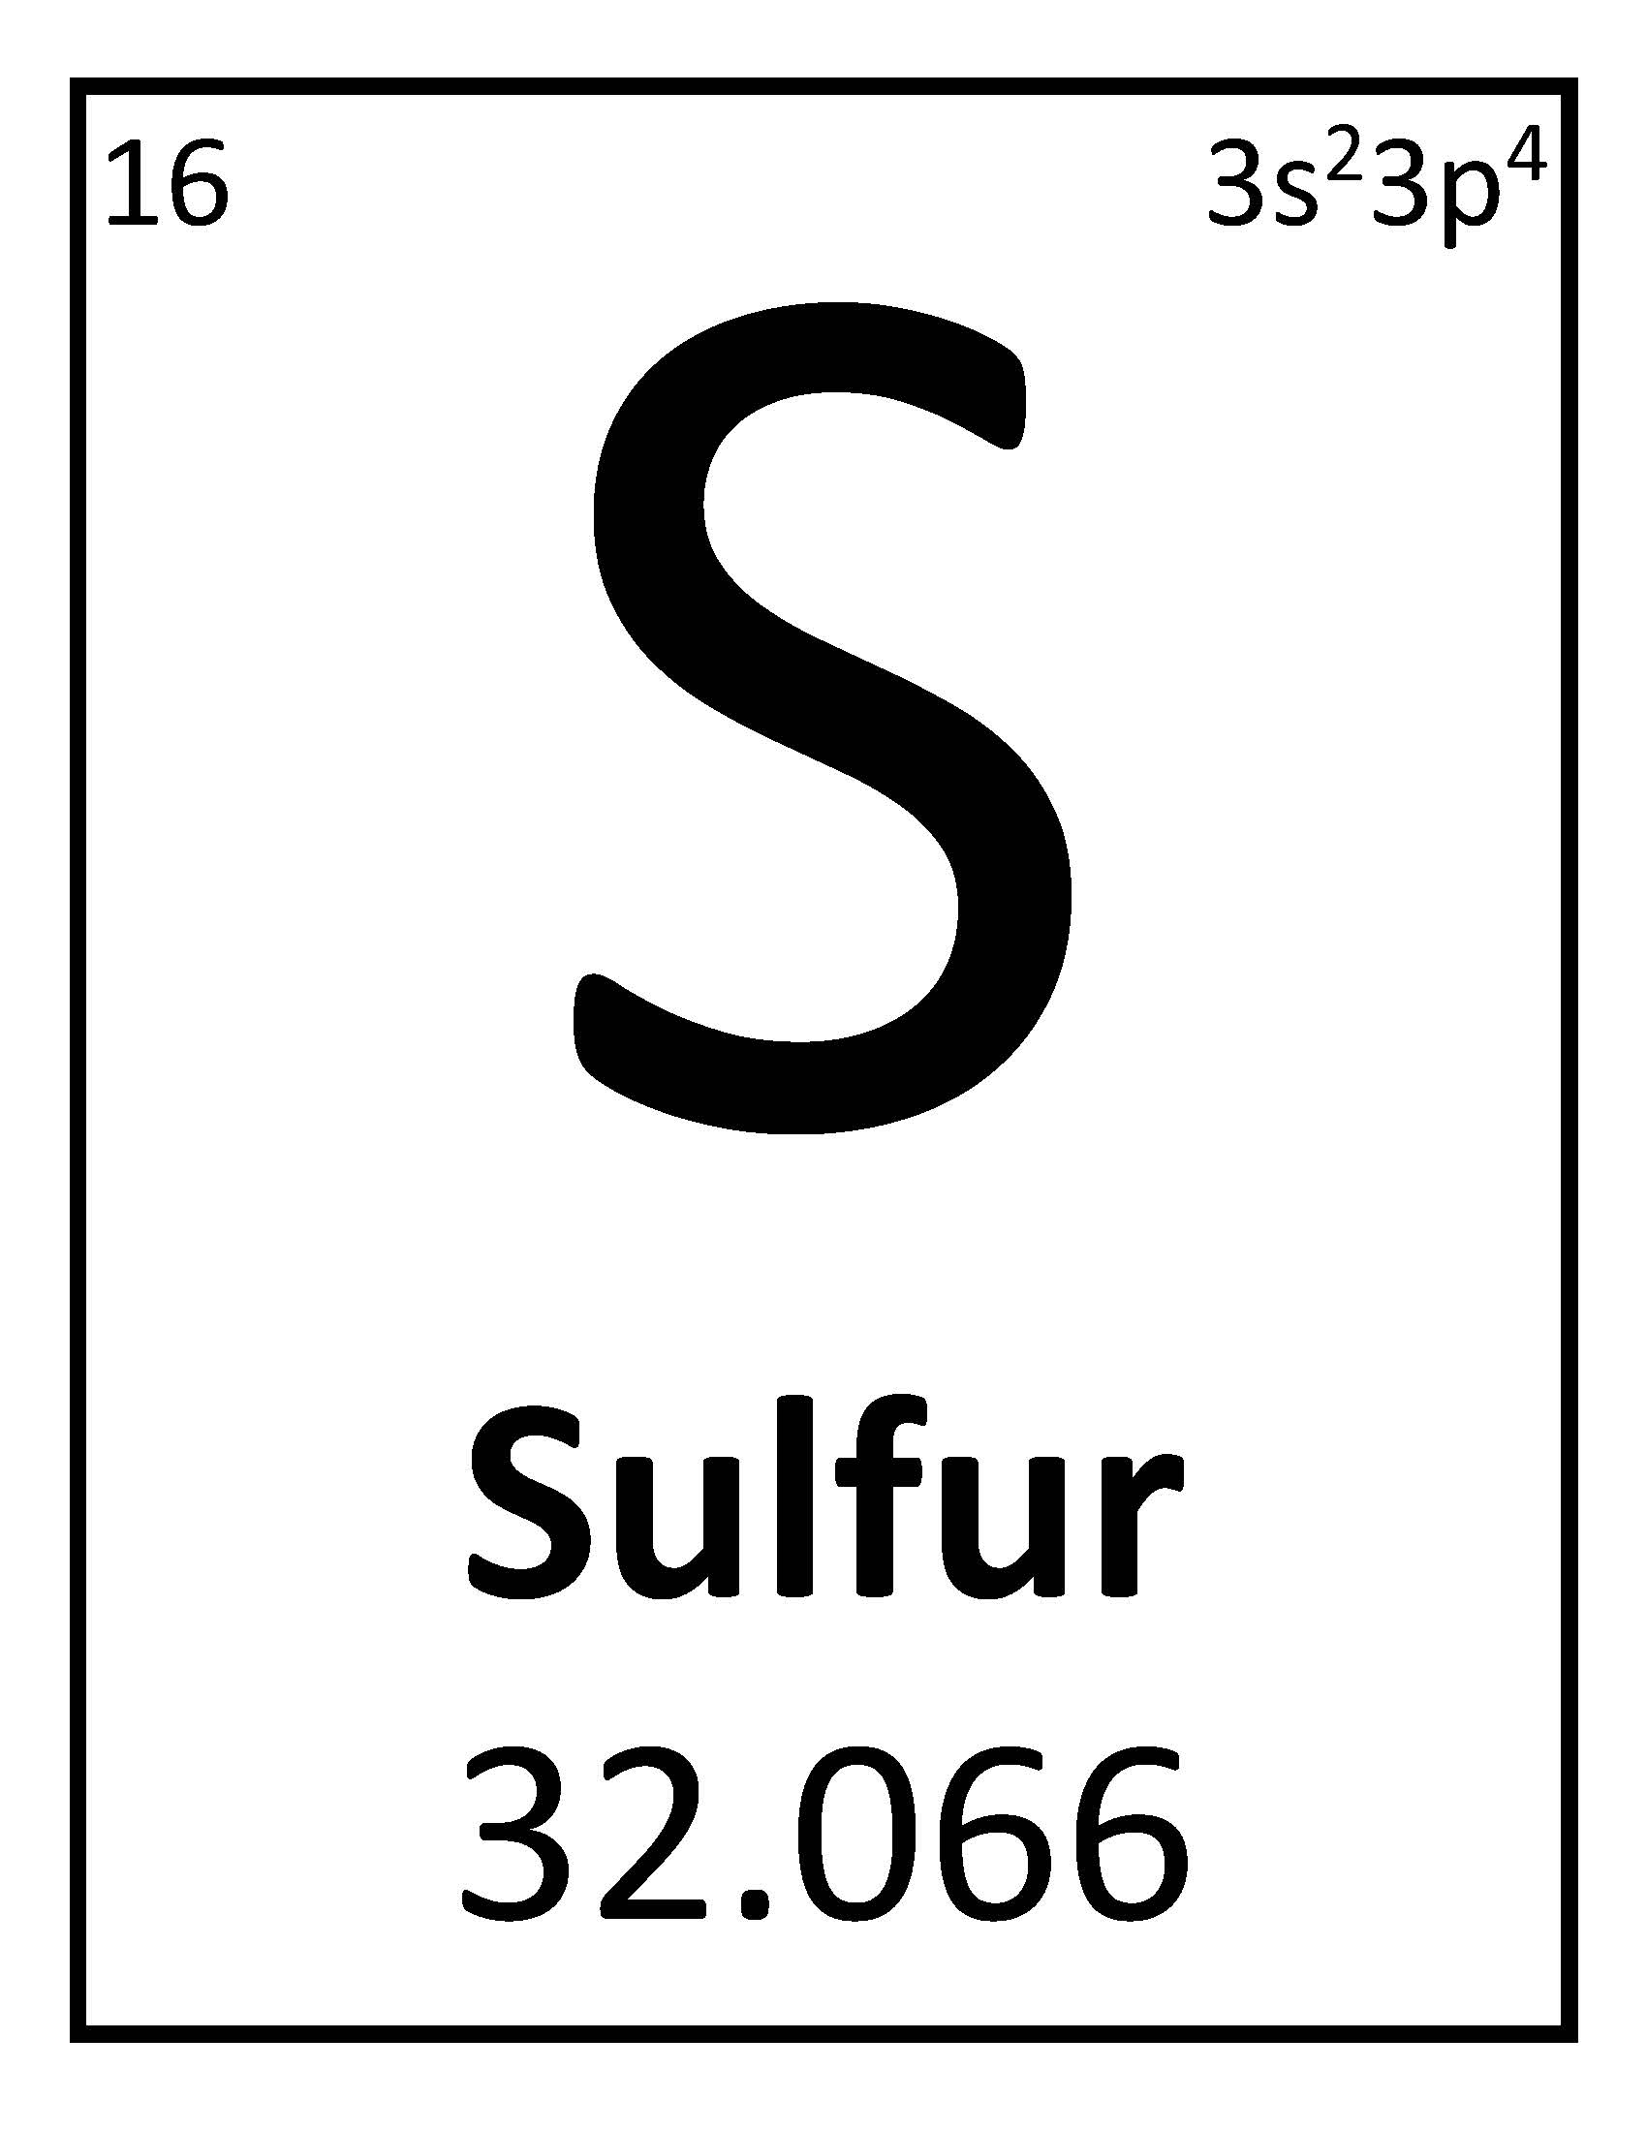
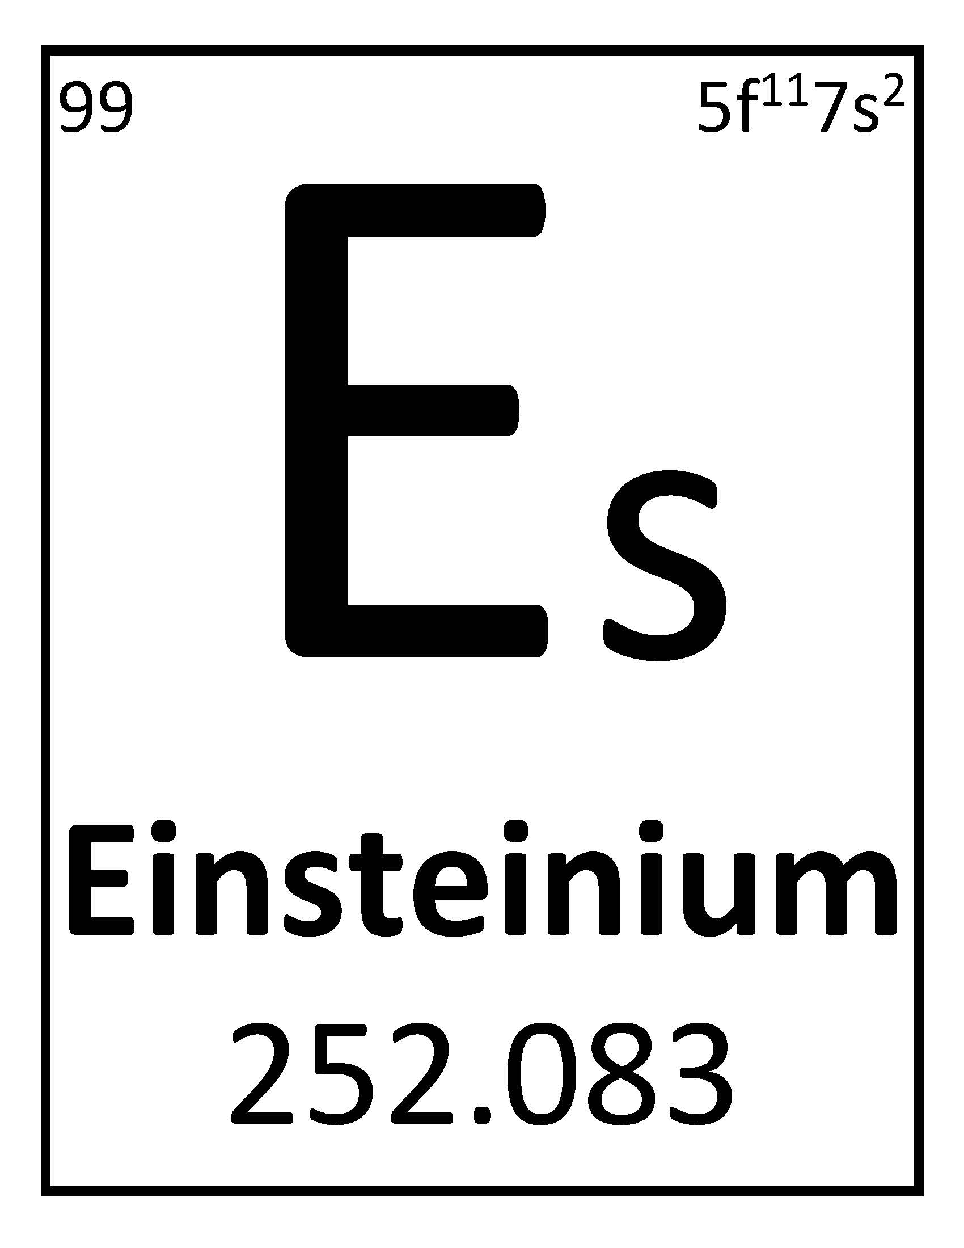
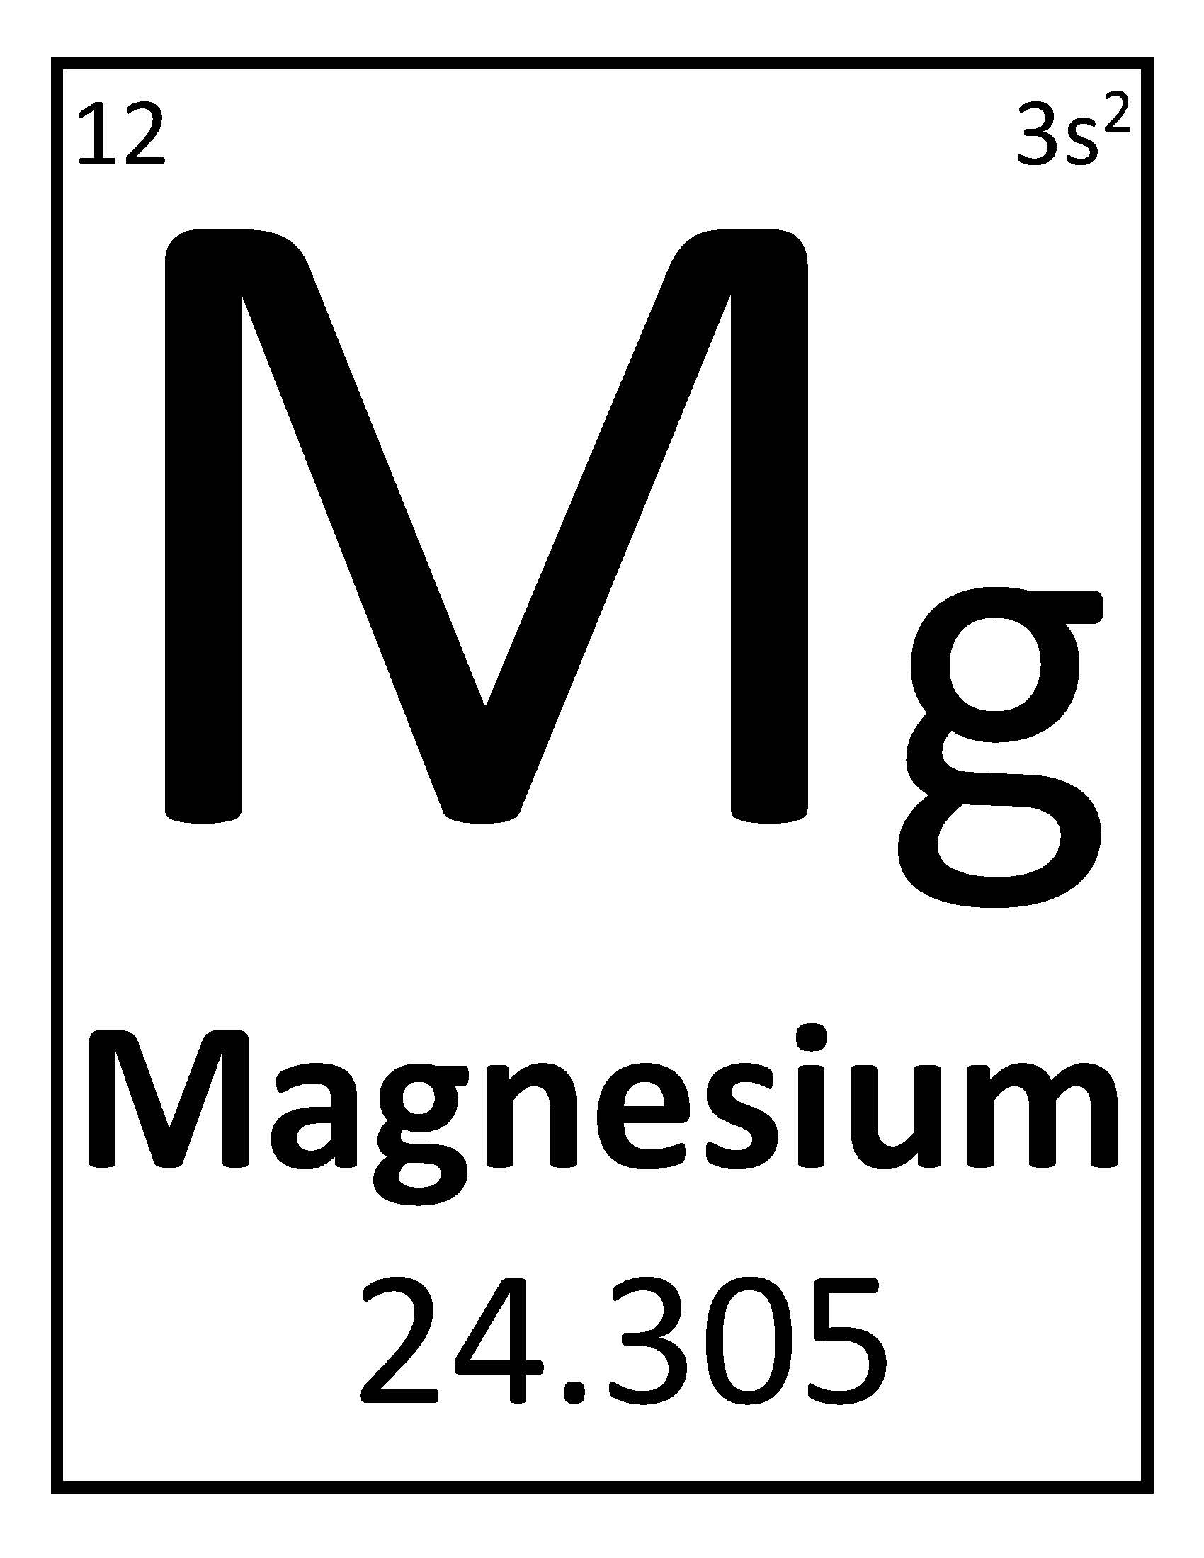
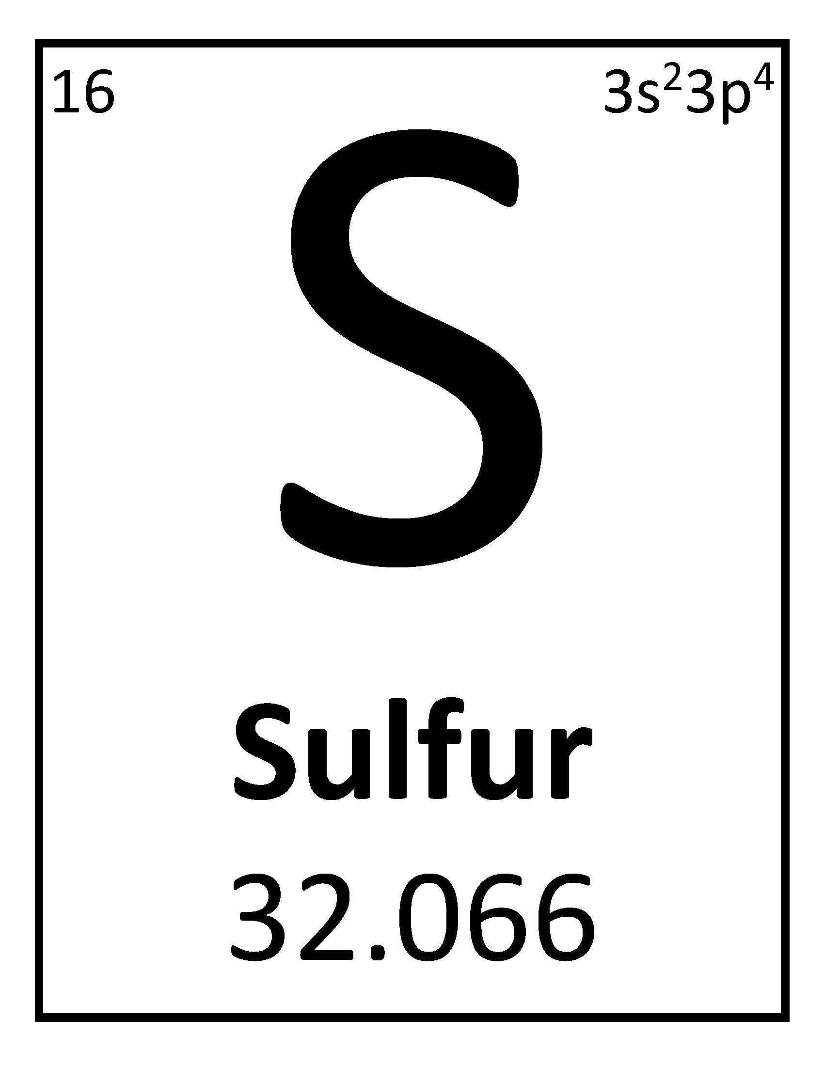
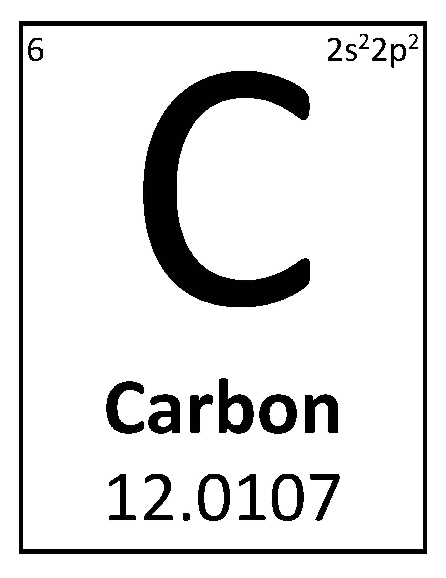
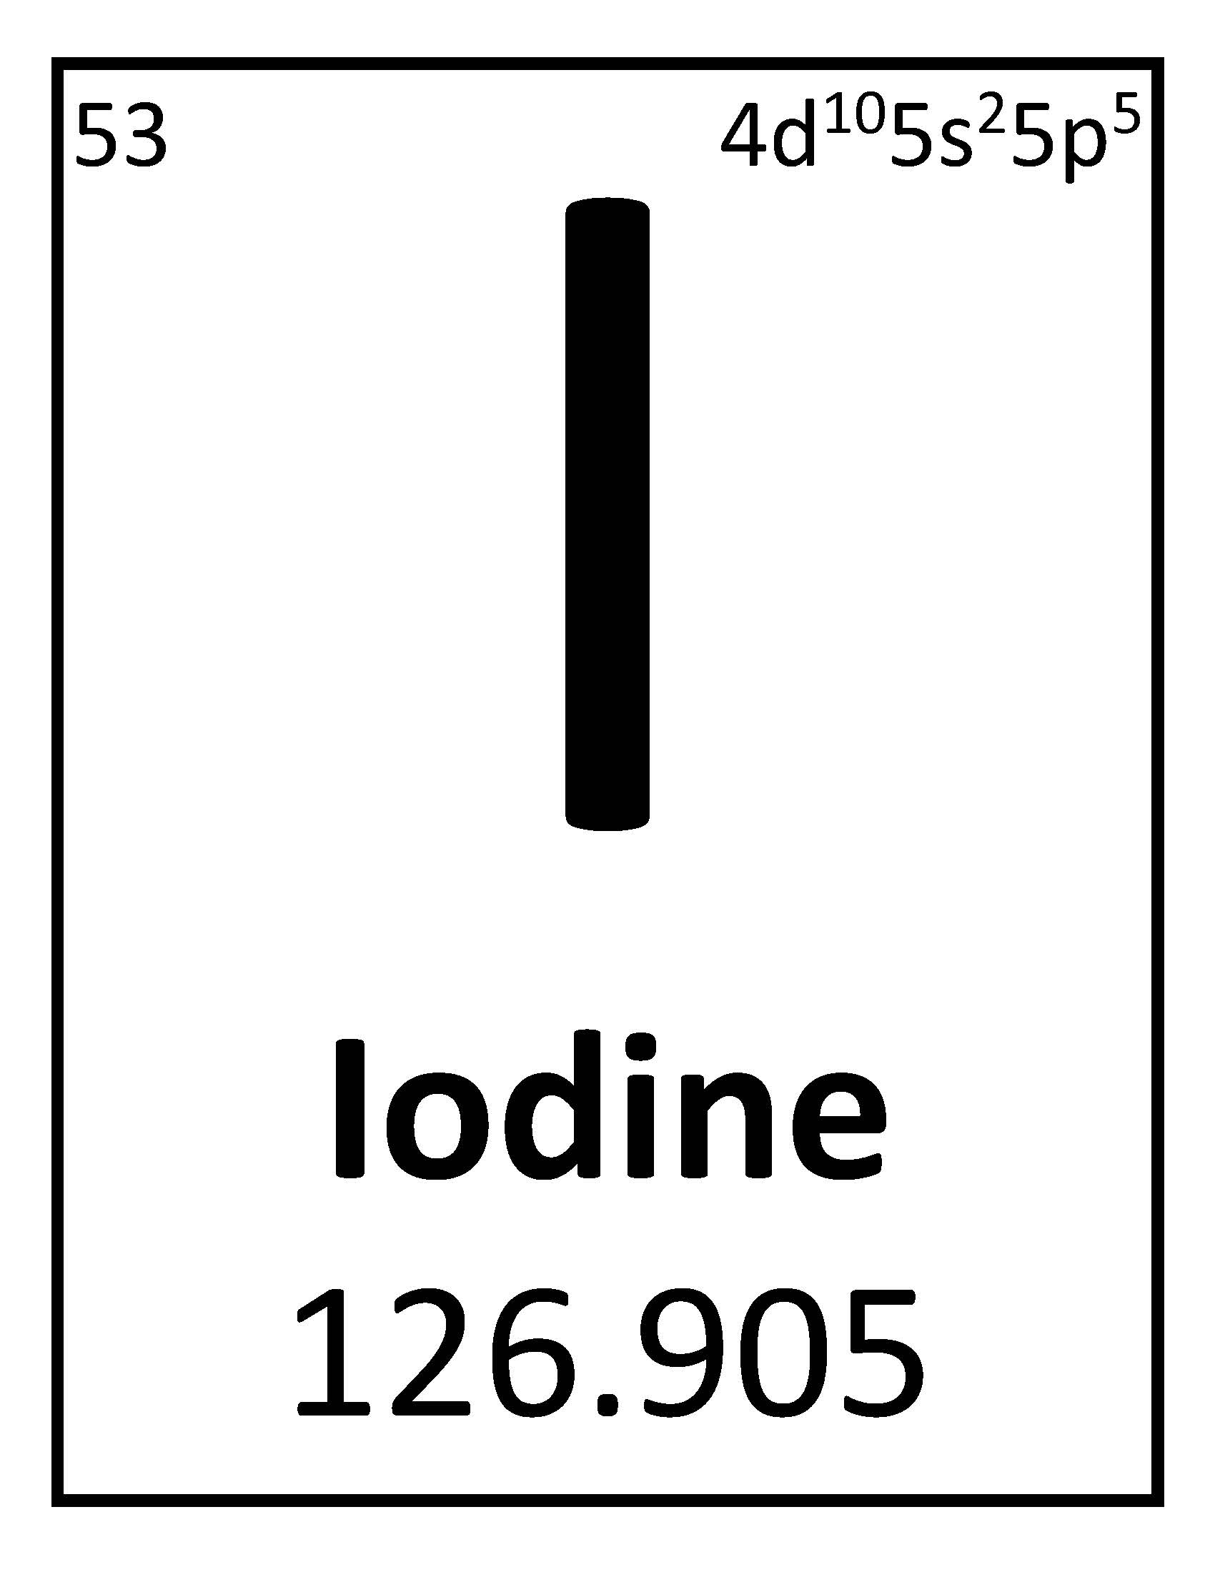
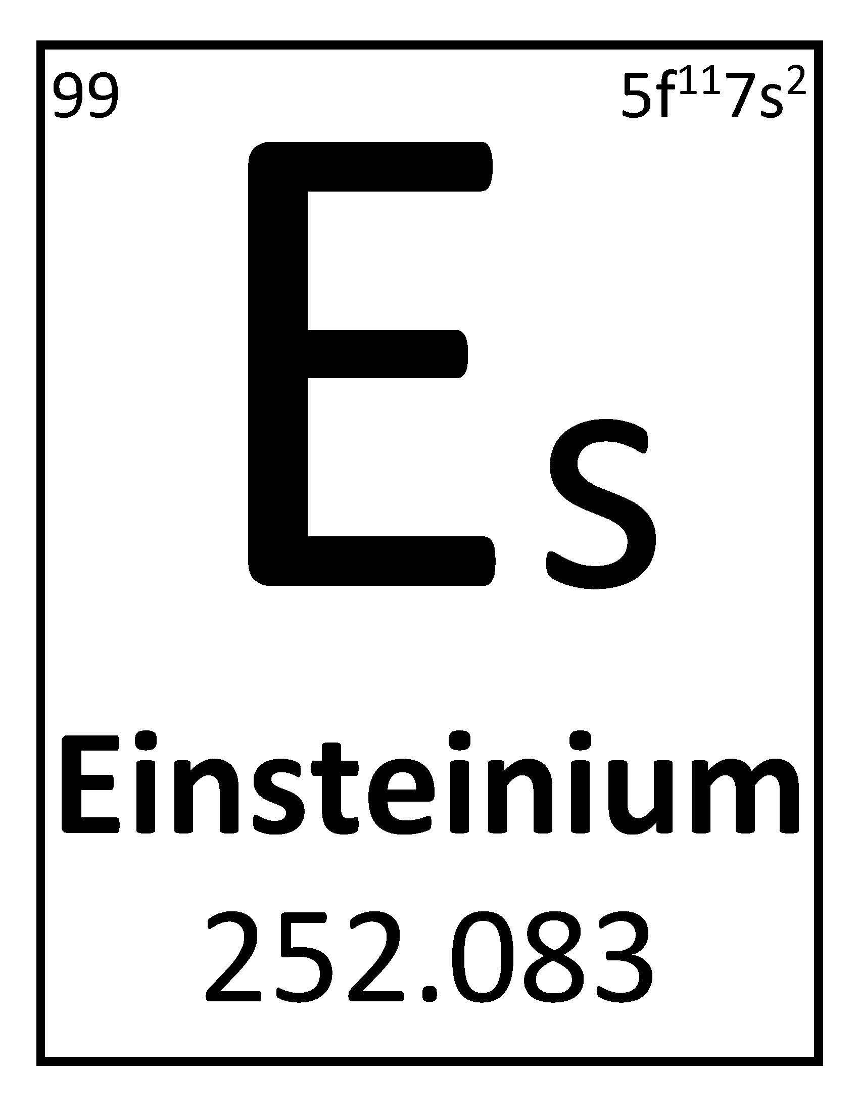
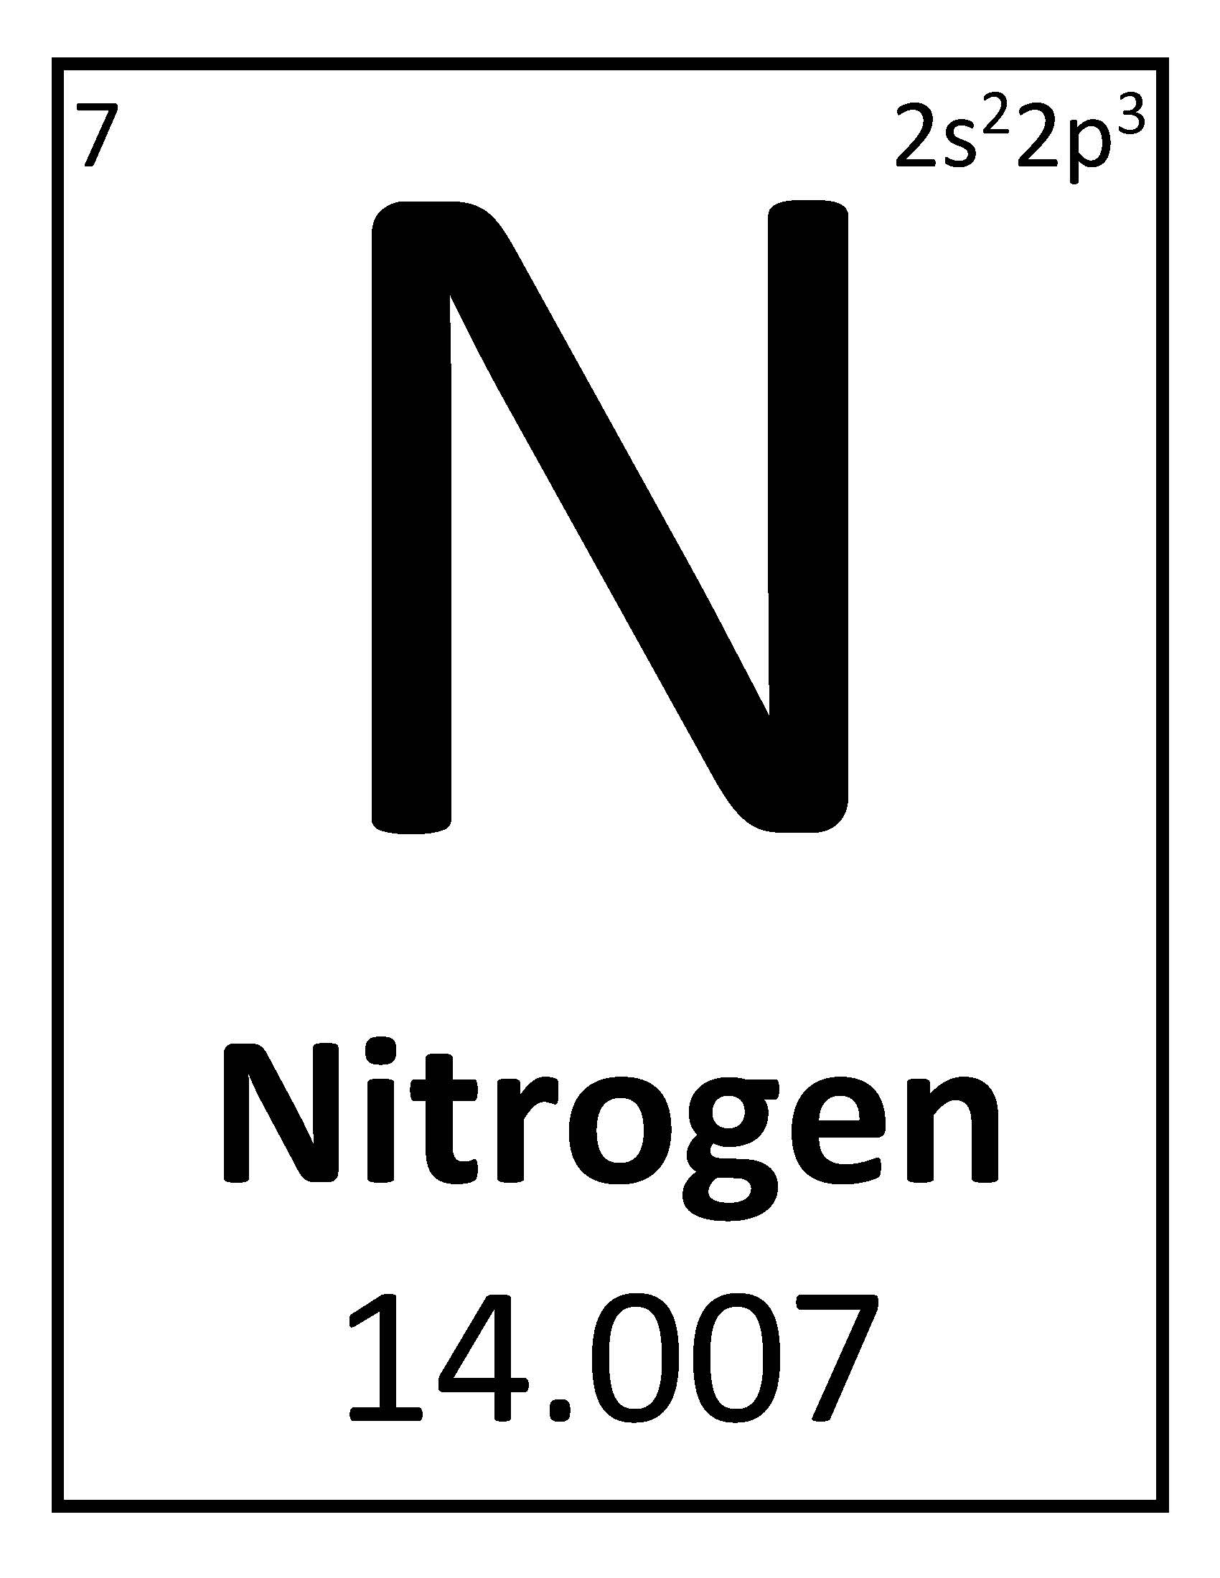
 | Pack 72 |  |  |  | February 2019
The Invention  Tune: The Farmer in The Dell  I had a genius kit,  Thought lots about it,  I laid the pieces side by side,  And examined them bit by bit.  A nut, a bolt, a screw,  A piece of wood too,  A leather scrap, some furry nap,  And a little bottle of glue.  A needle and some thread,  A nail without a head,  A piece of fire, a bit of wire,  And this is what I said:  “I don’t see how this mess,  Can really quite express,  My urge for building something grand,”  But now I must confess:  I sewed and nailed and glued,  Until the thing I viewed,  Was something grand, you understand,  A mechanical dog that mooed. |  |  | 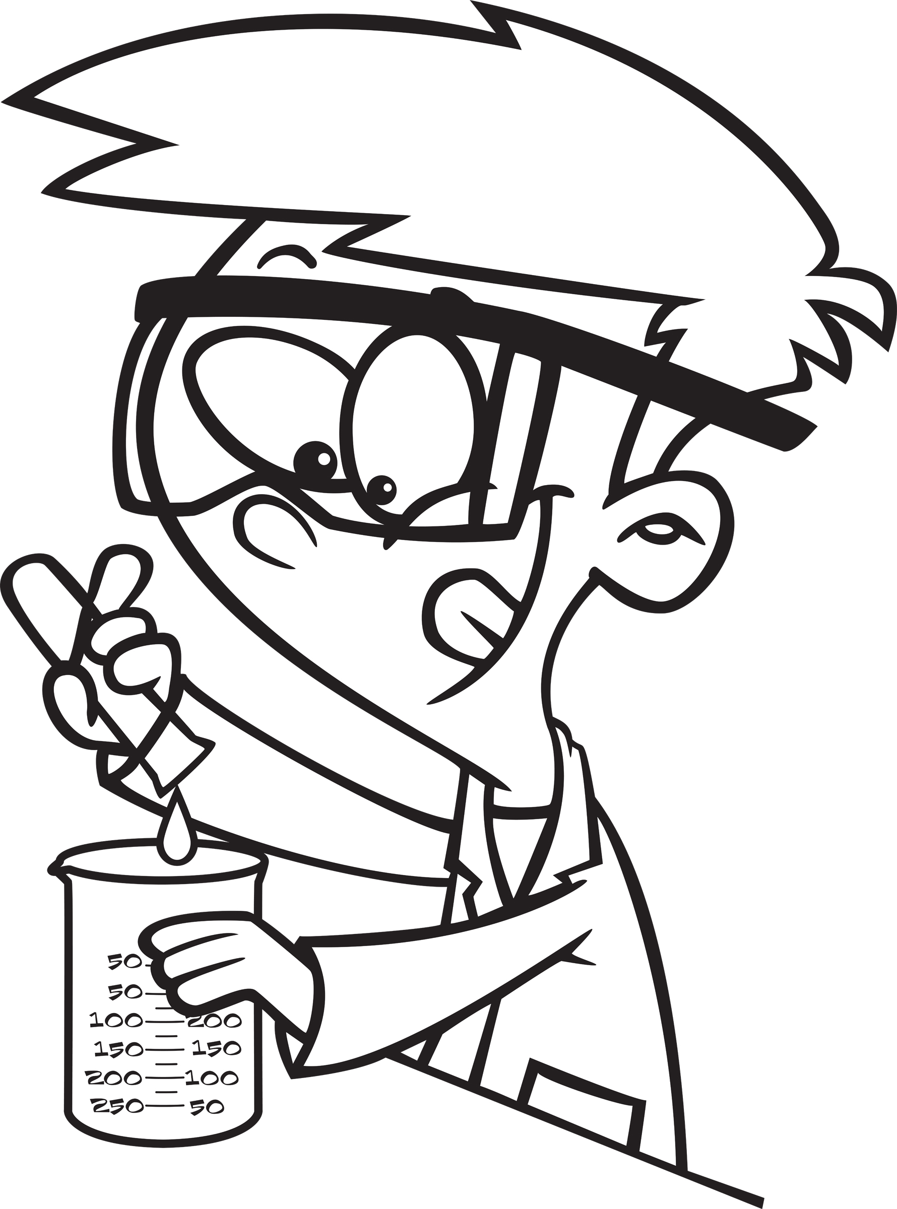 |  |  |  | January 2018  Jan 10 Den Meeting  Jan 24 Den Meeting  Jan 27 Scouting for Food  (hanger distribution)  Jan 31 Pack Meeting  February 2018  Feb 3 Scouting for Food  (food pick up)  Feb 7 Den Meeting  Feb 21 Den Meeting  Feb 23 Derby car check-in  Feb 24 Pinewood Derby and potluck lunch  Feb 28 Pack Meeting  March 2018  Mar 7 Den Meeting  March 24-25 Family Campout  Mar 28 Den Meeting  April 2018  April 4 Den Meeting  April 14 Scout Fair  April 18 Den Meeting  April 25 Pack Meeting  May 2018  May 2 Den Meeting  May 19 Banquet / Pack Meeting  June 2018  June 5-8 Day Camp: www.orion.shac.org/day-camp
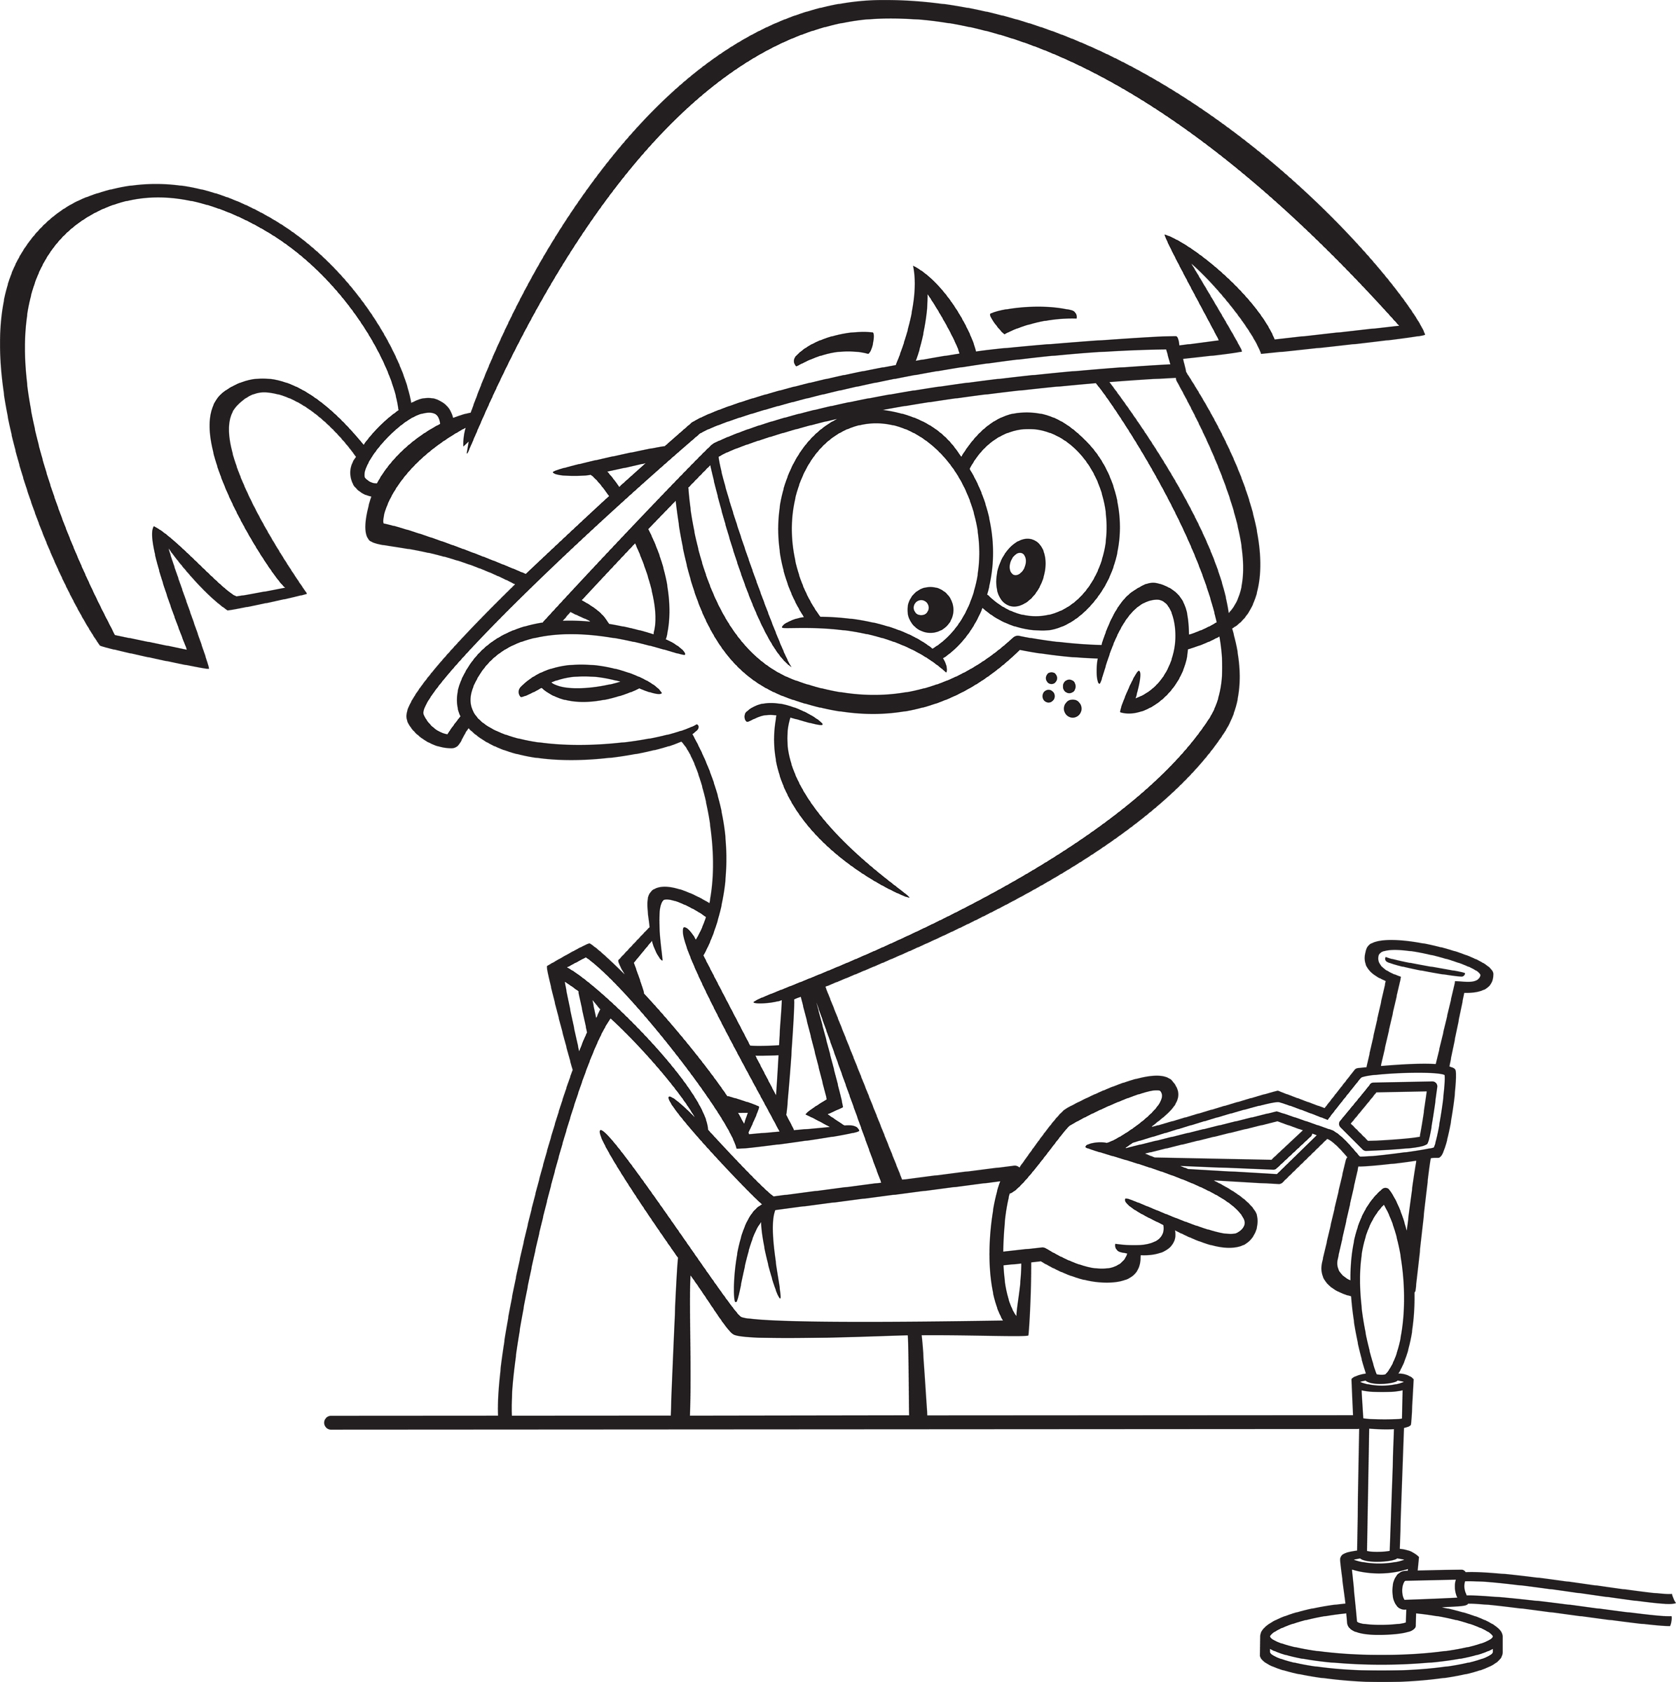 |  | Old Inventions  Tune: Auld Lang Syne  Should old inventions be forgot, -  And never brought to mind,  Just look in any antique shop  Old inventions you will find.  A Victrola, a wind-up toy,  An old telegraph key,  Inventions that brought hope and joy,  Don’t last eternally.  An automatic nose picker,  A top-coat made of flies,  A dried up envelope licker,  And jellies made from mice.  Inventions may be old and strange,  But we need new ones too.  Who’ll find the cure for fleas and mange,  That inventor may be you.
Pack 72
facebook.com/pack72tomball
pack72tomball.scoutlander.com
Orion District
www.orion.shac.org
facebook.com/orionbsa
Sam Houston Area Council
www.shac.org
facebook.com/shac.bsa

PROGRAM

Print the program front to back.

An editable, word version of this document is available at www.shac.org/science-theme

Check back frequently for updates.
May 19, 2018
Pack 72
Blue and Gold
Banquet
Lions  Owen Barnes  Luke Howland  Rayden Johnson  Nikolas Ramin  Tigers  Henry Kahle  Lucas Smiles  Wolves  Connor Anderson  Keegan Crawford  Troy Douglas  Haiden Idrobo  Cameron Scheffler  Cooper Trent  Parker Wrieden |  | Bears  Kameron Brown  Michael Parks  Aiden Stanolevich  Webelos Scouts  Thomas DeLaCruz  Colt Douglas  Joshua Hill  Brayden Lewis  Eric Matute  Jared Olivares  Cadoc Shillings

Upcoming Events
June 3 Pack planning meeting
June 12-16 Twilight Camp, www.orion.shac.org
July Resident Camp, shac.org/resident-camp
July 7 Troop 1907 Fun Day
July 28 Pack Water Day
August 12 Pack Bowling

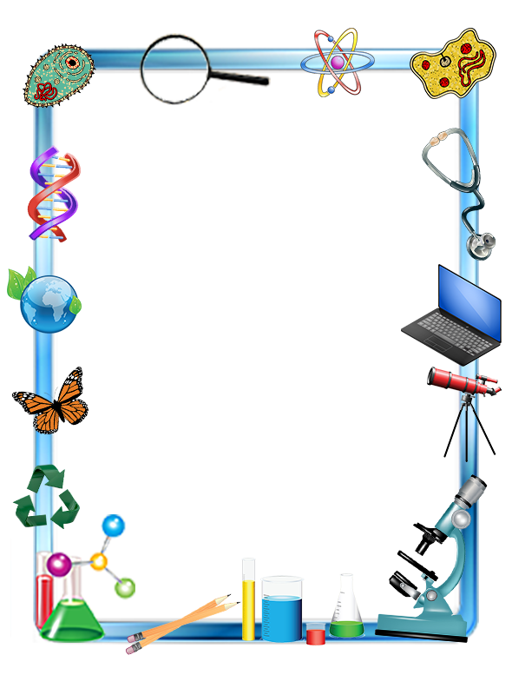
The Invention
Tune: The Farmer in The Dell
I had a genius kit,
Thought lots about it,
I laid the pieces side by side,
And examined them bit by bit.
A nut, a bolt, a screw,
A piece of wood too,
A leather scrap, some furry nap,
And a little bottle of glue.
A needle and some thread,
A nail without a head,
A piece of fire, a bit of wire,
And this is what I said:
“I don’t see how this mess,
Can really quite express,
My urge for building something grand,”
But now I must confess:
I sewed and nailed and glued,
Until the thing I viewed,
Was something grand, you understand,
A mechanical dog that mooed.

Old Inventions
Tune: Auld Lang Syne
Should old inventions be forgot, -
And never brought to mind,
Just look in any antique shop
Old inventions you will find.
A Victrola, a wind-up toy,
An old telegraph key,
Inventions that brought hope and joy,
Don’t last eternally.
An automatic nose picker,
A top-coat made of flies,
A dried up envelope licker,
And jellies made from mice.
Inventions may be old and strange,
But we need new ones too.
Who’ll find the cure for fleas and mange,
That inventor may be you.

Gathering

Opening

Invocation

Dinner

Friends of Scouting Presentation

Advancement Ceremony

Song

Leader Recognition

Cubmaster Minute

Closing
www.facebook.com/pack72tomball
www.facebook.com/orionbsa
www.facebook.com/shac.bsa
www.orion.shac.org
www.shac.org

